

**RELEASE NOTES**

**KSCIT SOLUTIONS**

**By:**

**S. Aravindan  
(Developer)**

Table of Contents

1. Introduction 3

2. About This Release 3

3. Compatible Products 3

SpotJo Release Notes

Introduction

The document communicates the major new features and changes in this release of the SpotJo Mobile App. It also documents known problems and workarounds.

# Compatible Products

This product has been tested on the following platforms or with the following products:

* Android

# Bugs Fixed

## GuestFlow – Choosing Skills

**DEFECT DESCRIPTION:**

In the guestflow, when we are choosing skills, and when we are searching for a skill, if that particular skill is already selected, when we click on that selected skill, then the skill gets deselected. So to fix that, we will add a condition to the code.

**SOURCE CODE FIX DONE:**

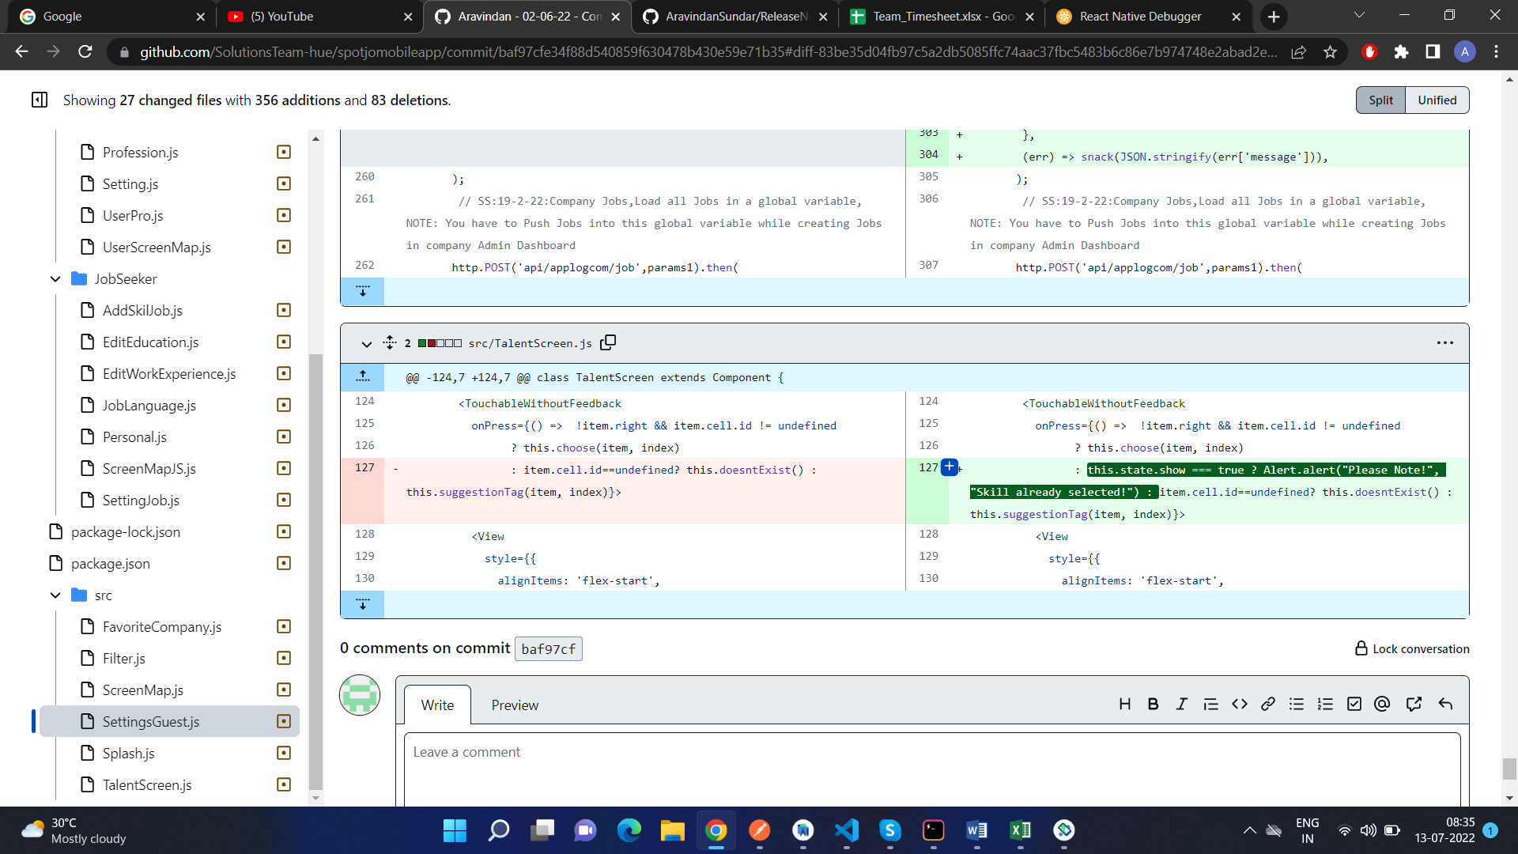

Here is how the page looks like after the code change:

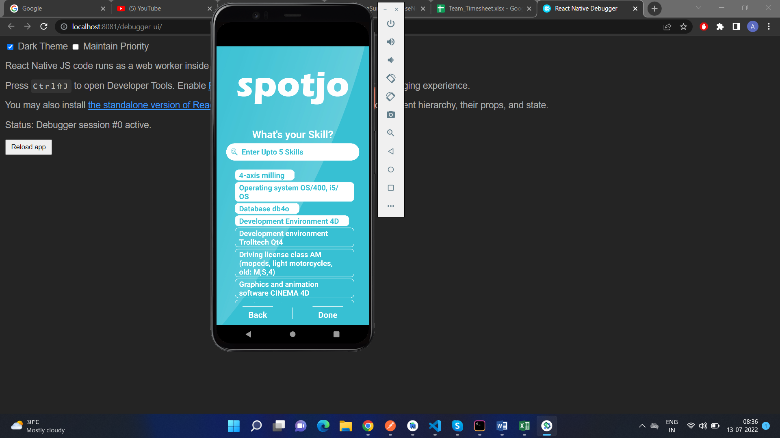

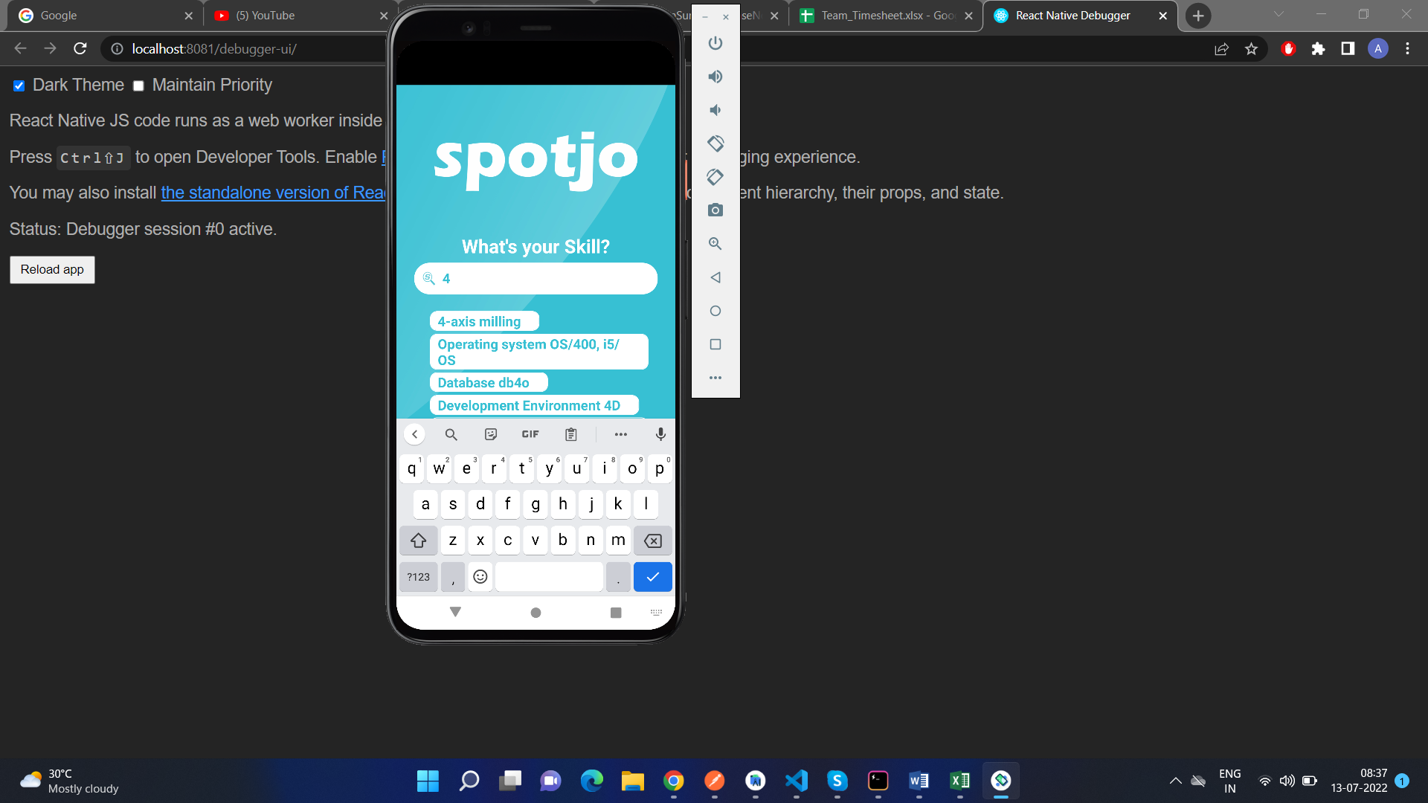

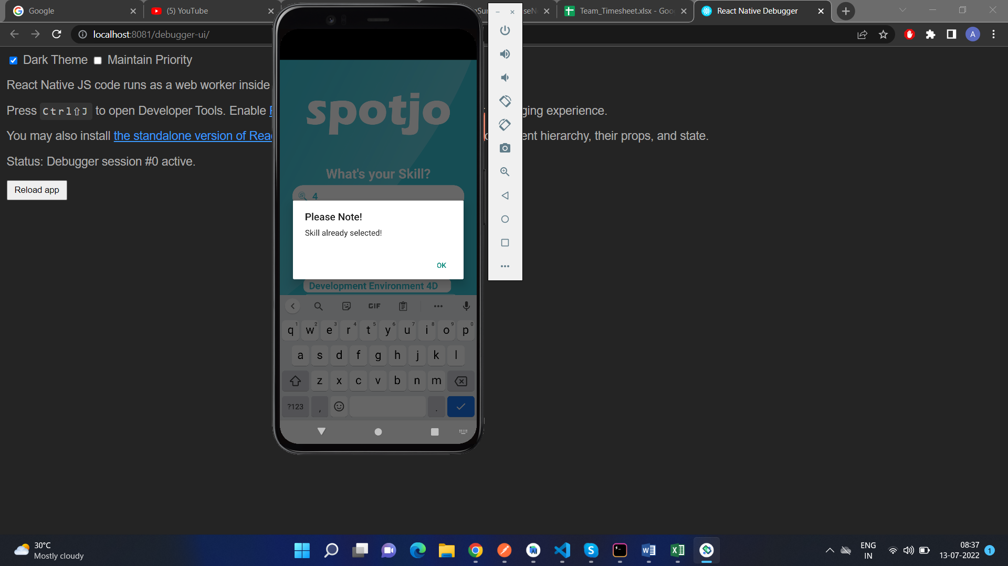

As can be seen in the screenshots, when we click on an already selected skill, we get an alert that says “Skill already selected”.

## Favourite Company bug

**DEFECT DESCRIPTION:**

In the guestflow, when we are choosing the company, we are able to choose the company of our choice and we are also able to click on the “All” button. It should not be like that. When we choose a company, and we click on the “All “ button, all the companies that we chose should disappear.

**SOURCE CODE FIX DONE:**

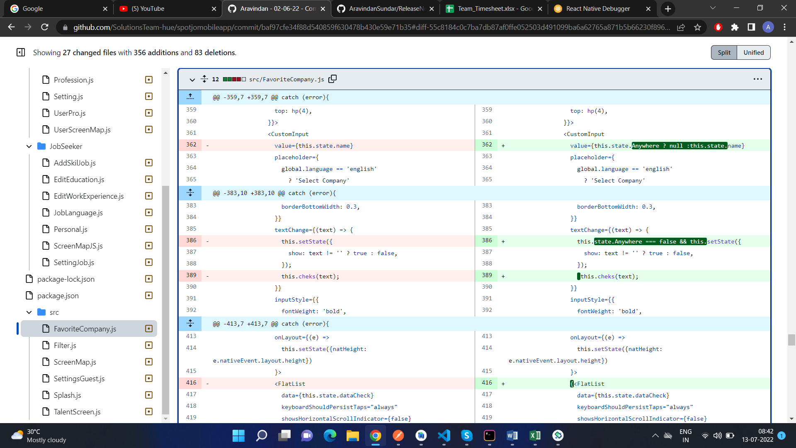

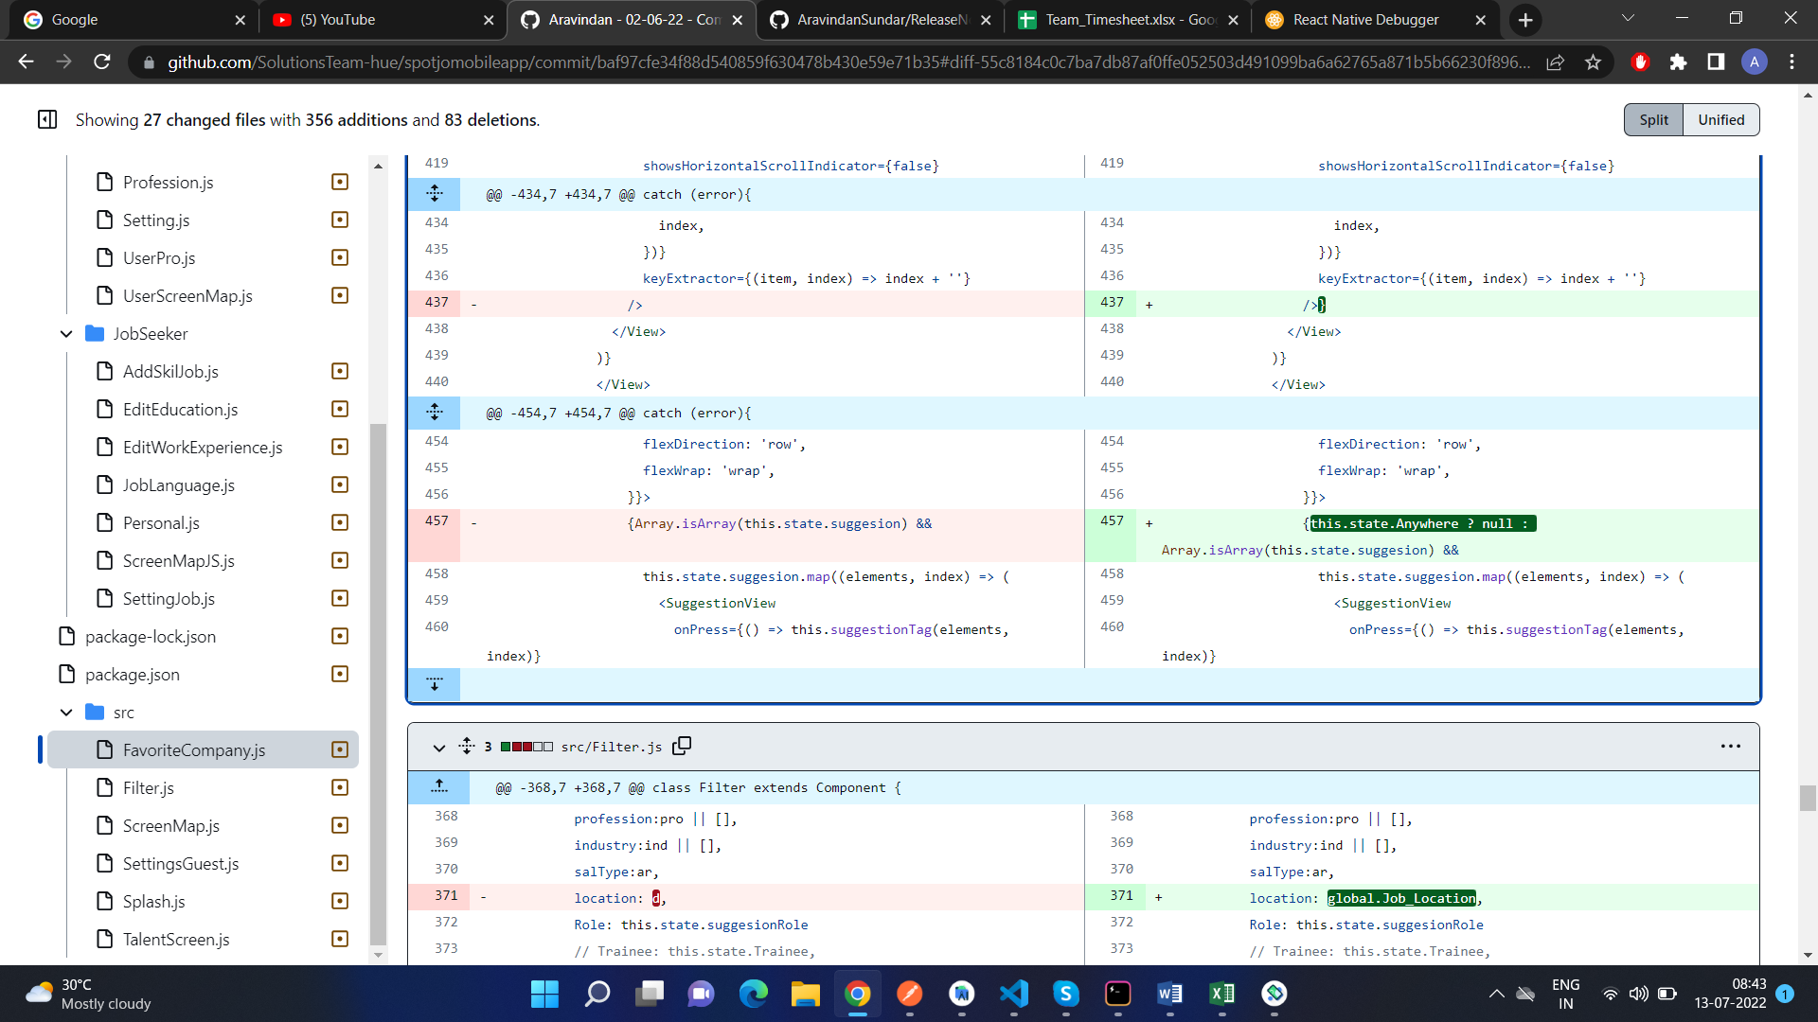

Here is how the page looks like after the code change:

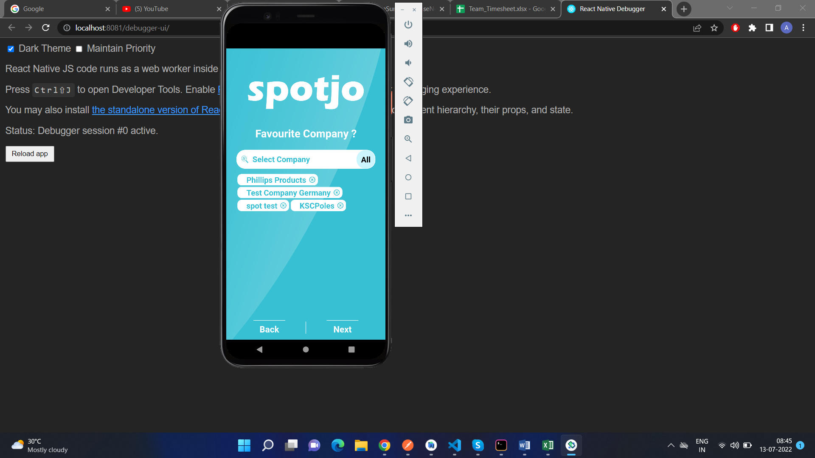

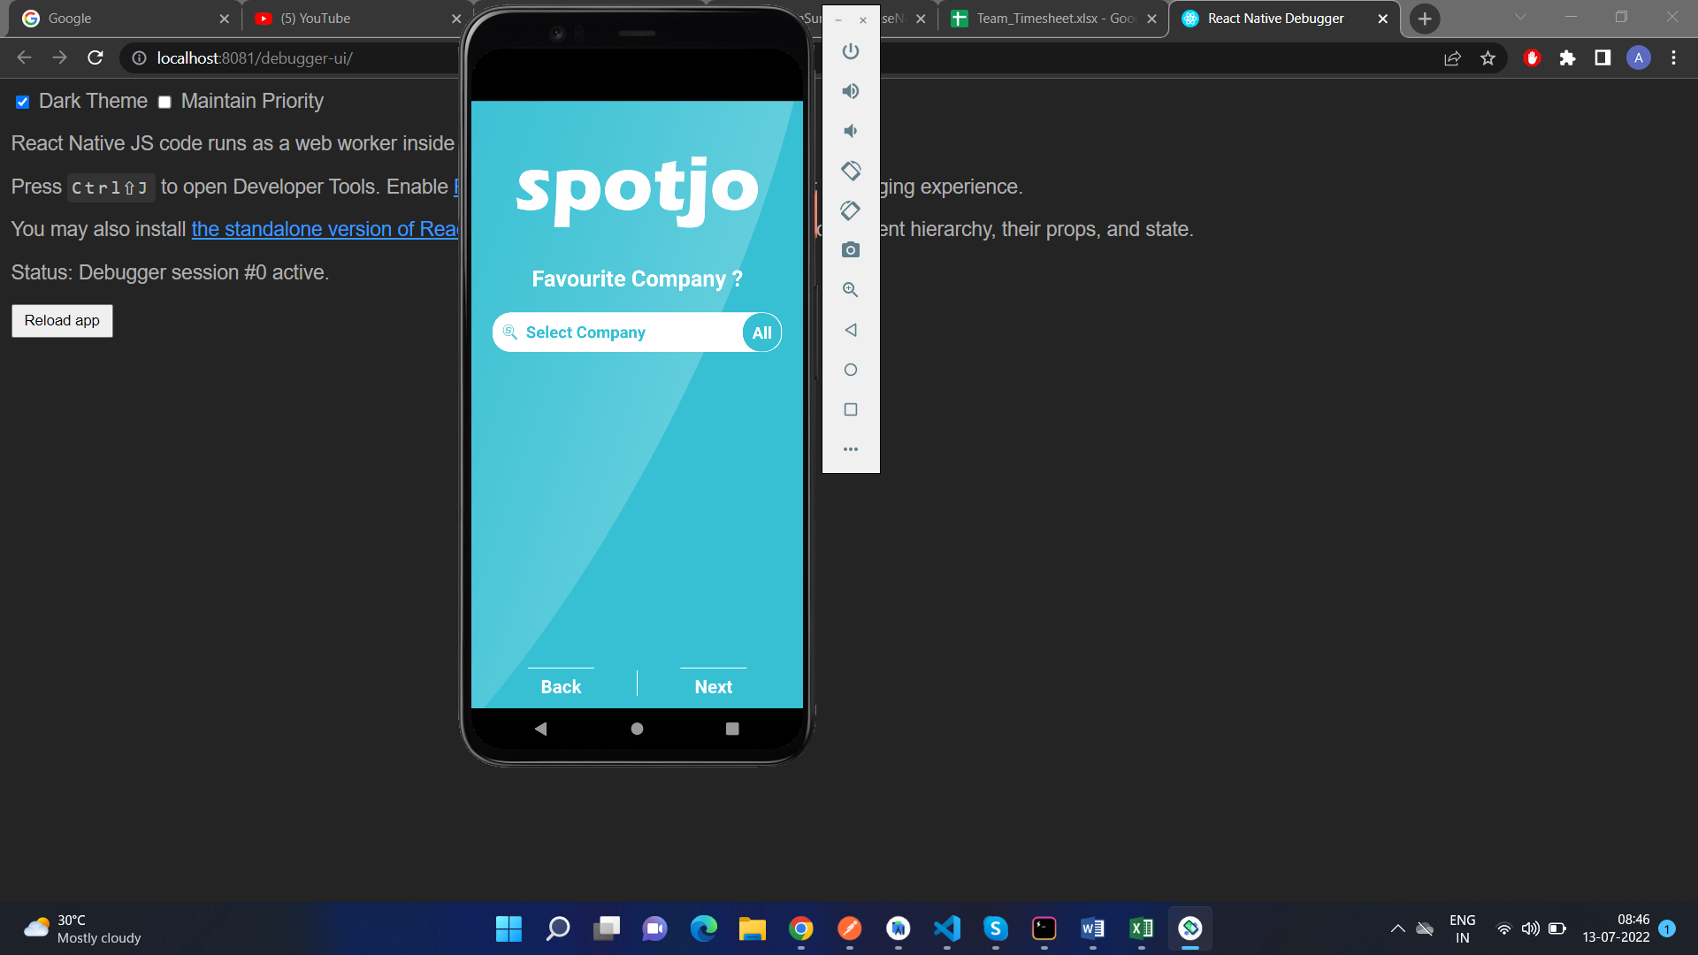

As can be seen in the screenshots, we are able to choose the companies of our choice but when we press the “All” button, all of the choices will gone.

## Filter bug:

**DEFECT DESCRIPTION:**

In the guestflow, when we reset the filter and we click on the “Back” button, and when we get to the Location page, we get an error saying “Unable to read Latitude..”. So to fix that we will have to make some changes in the Filter page’s code.

**SOURCE CODE FIX DONE:**

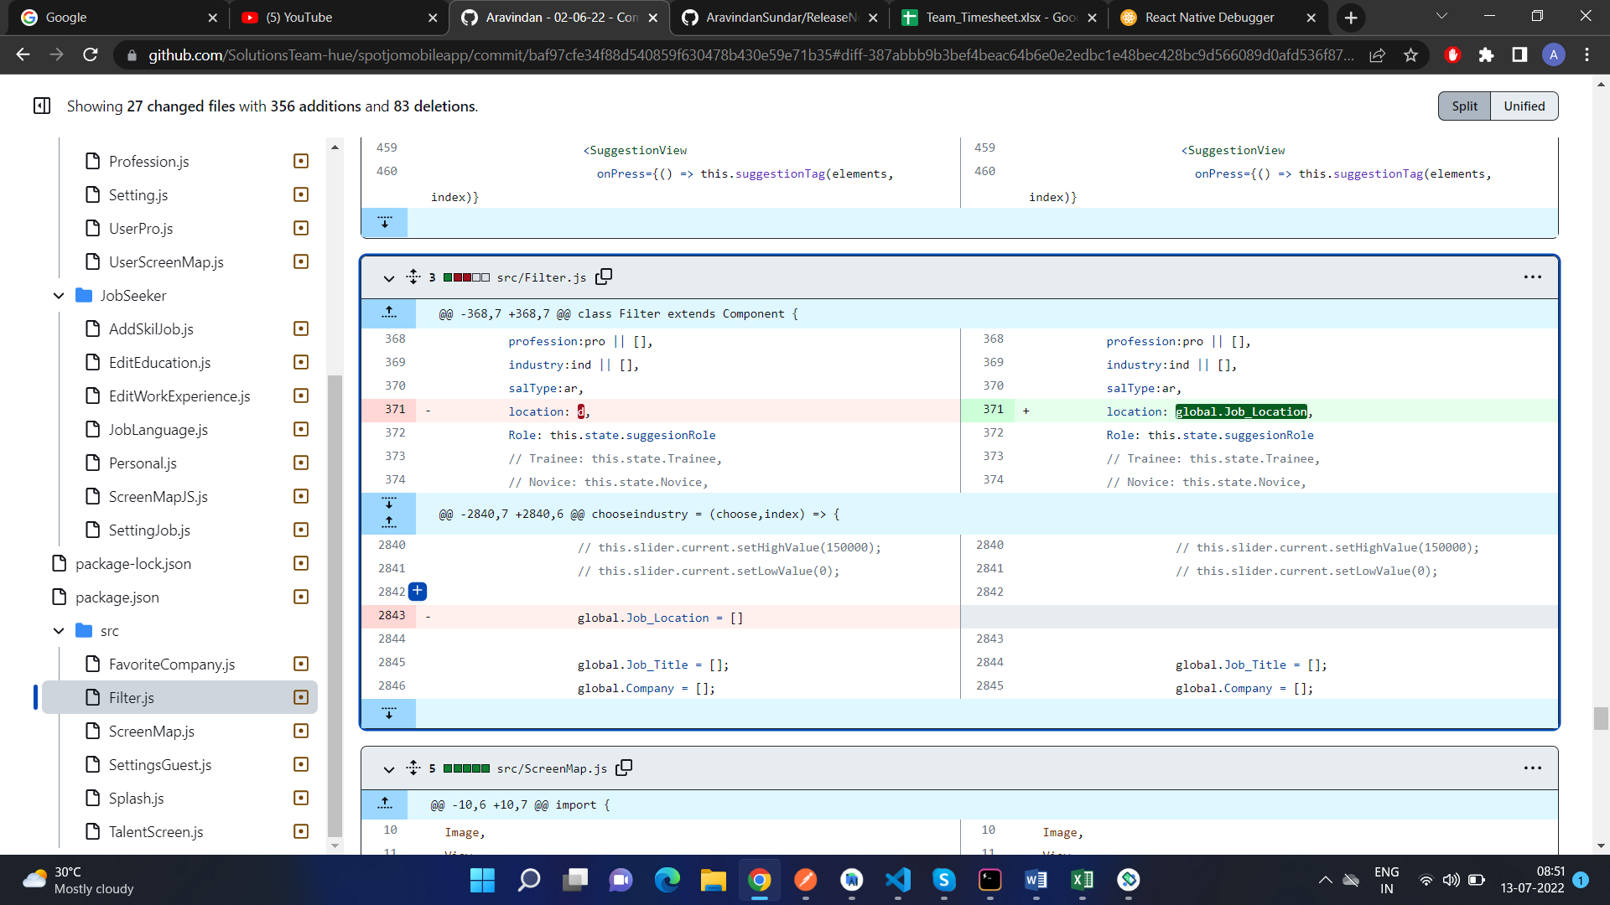

Here are screenshots of how the page looks like after we added the code change:

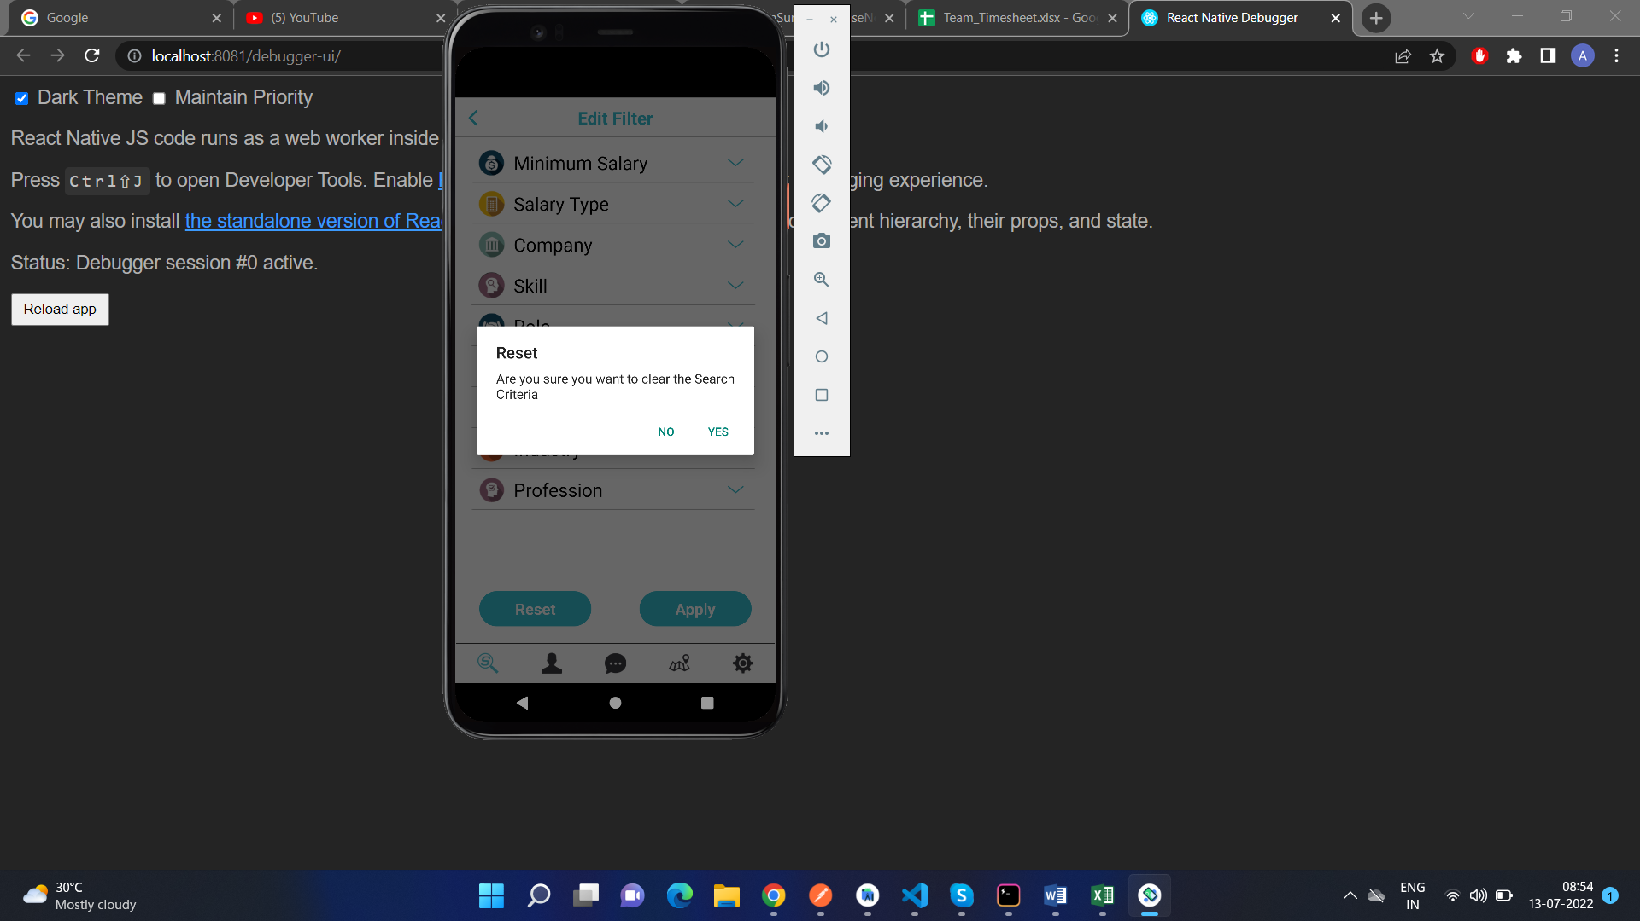

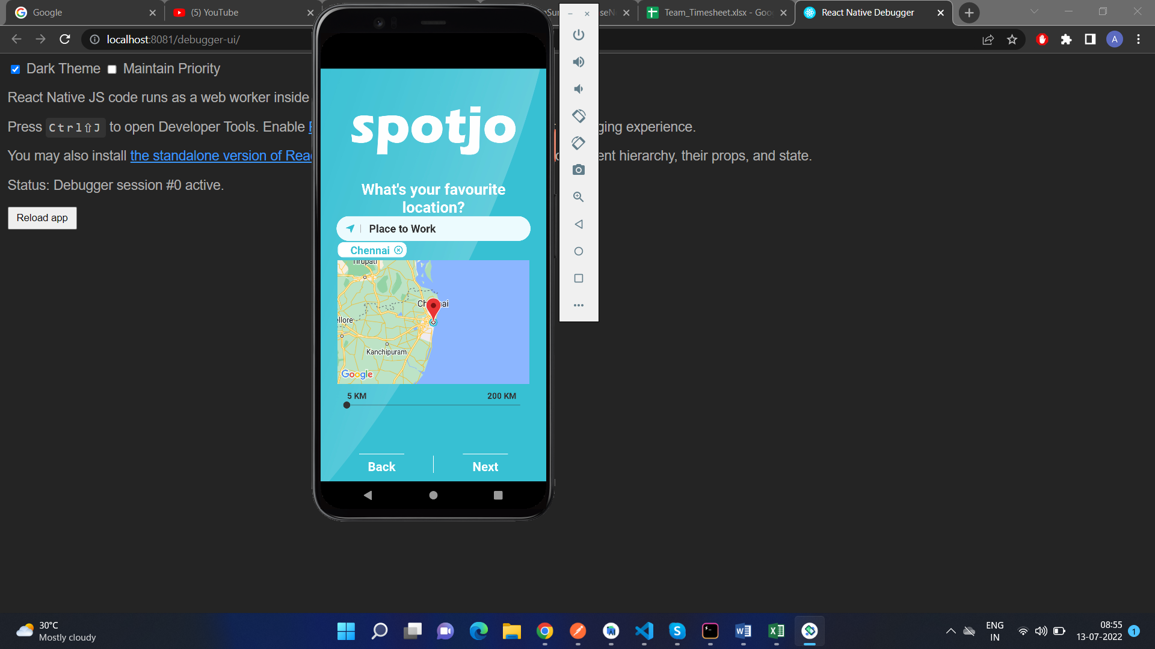

As can be seen when we click on the “Back” button and we get to the location page, the app doesn’t give us an error.

## Version Error in all views

**DEFECT DESCRIPTION:**

When we are going to the settings to check the version of the app that we are using, it used to say “Version NaN”. So to fix that, we will have to check the api that is being called to display the version number.

**SOURCE CODE FIX DONE:**

**Guestflow:**

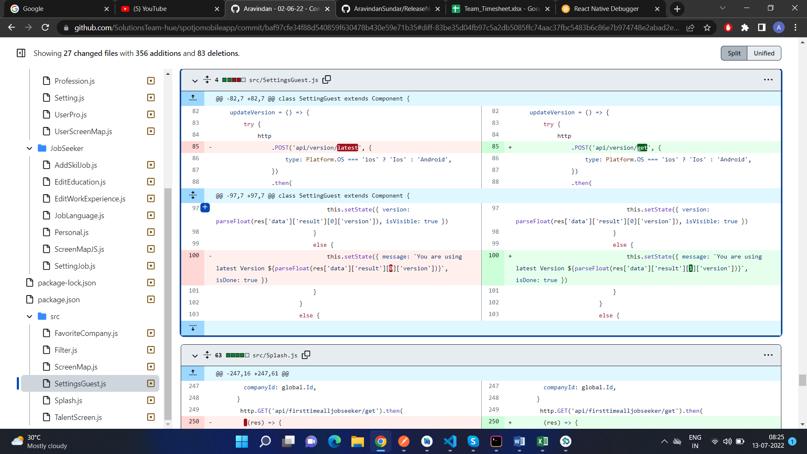

**Jobseeker:**

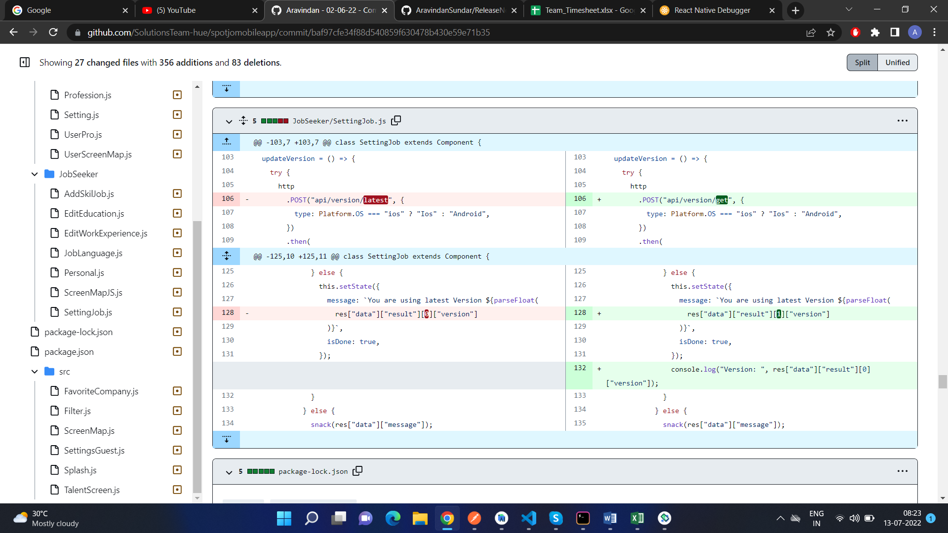

**Company Admin:**

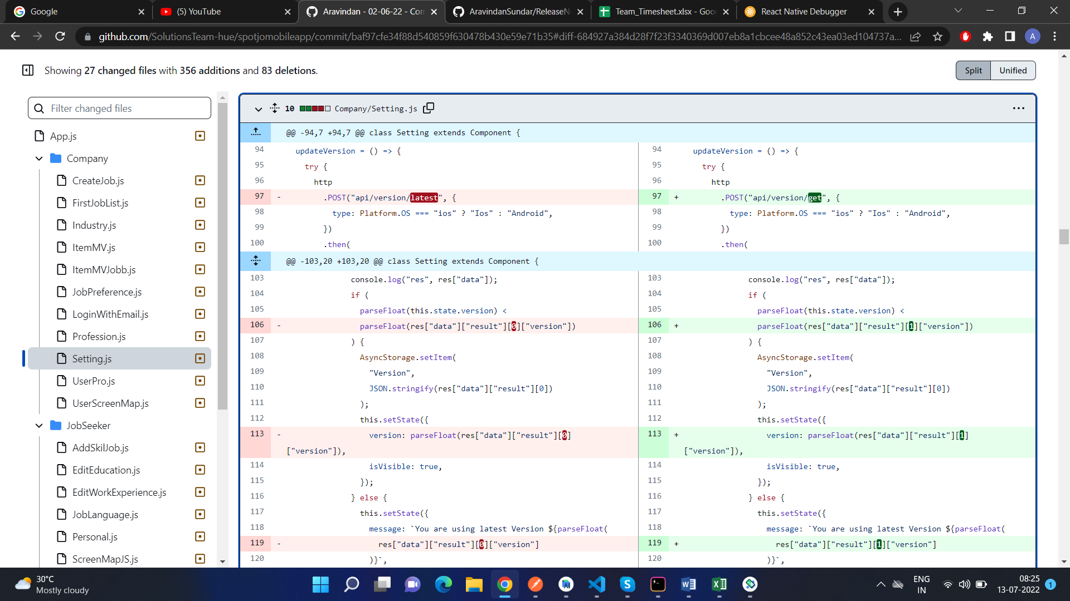

Here is how the page looks like after the code change:

Guestflow:

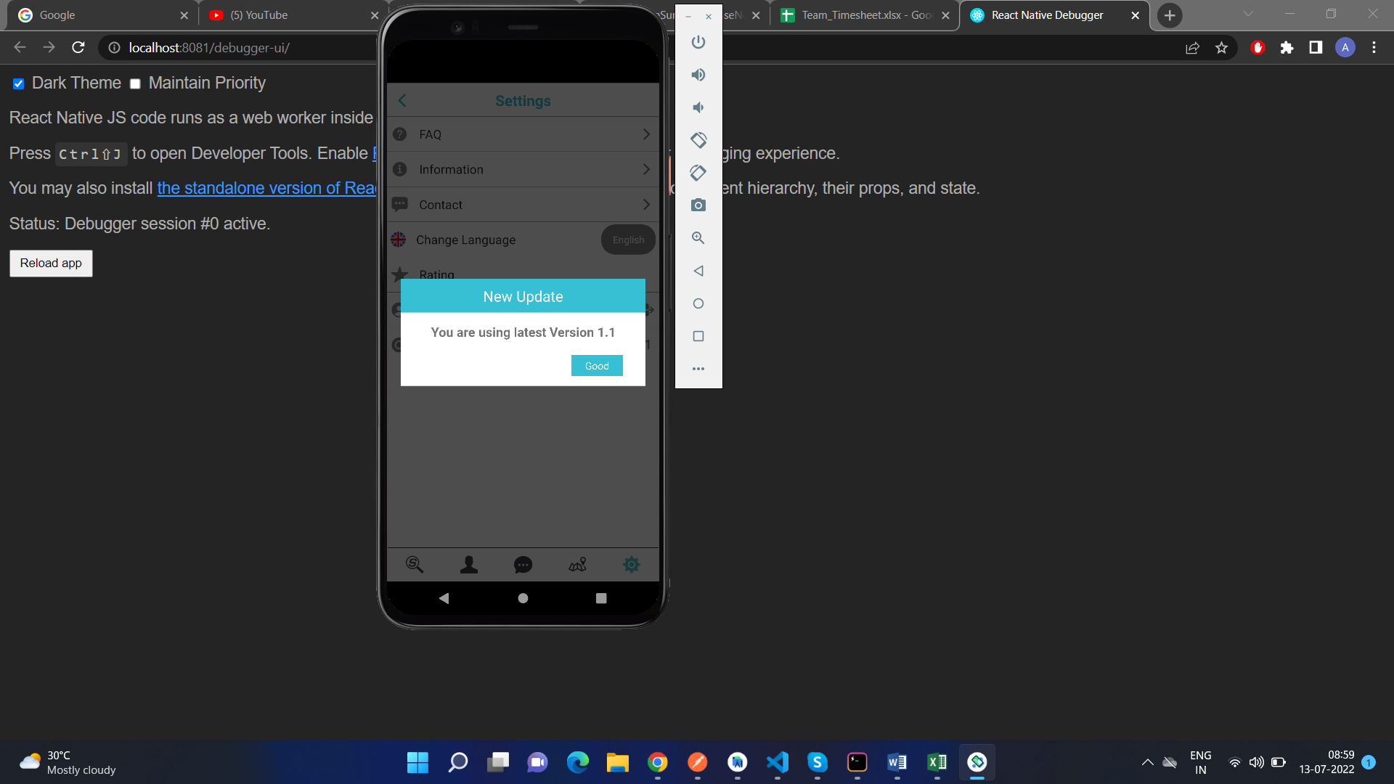

Jobseeker:

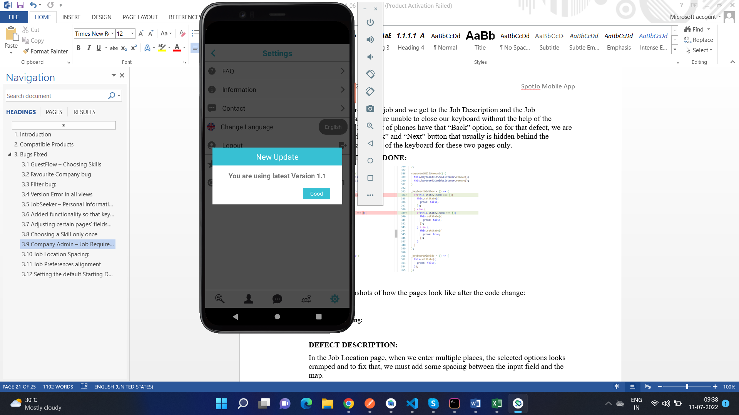

Company Admin:

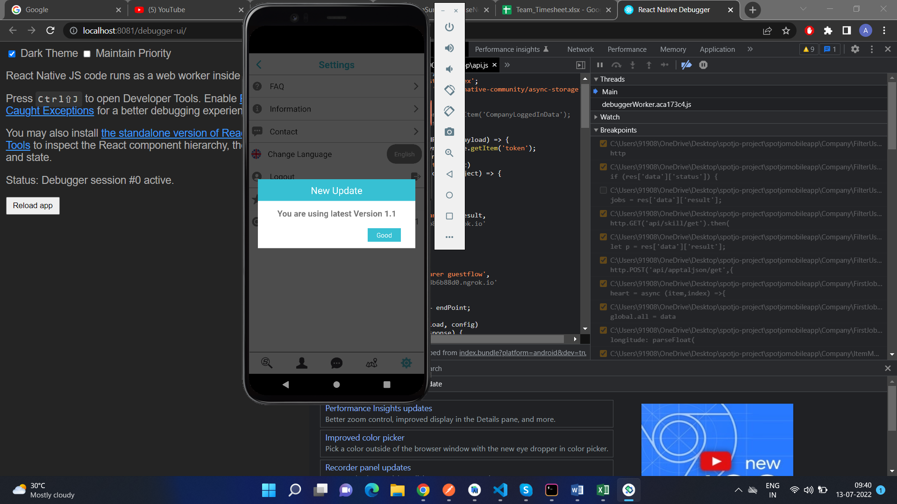

As can be seen in the screenshot, the popup no longer says “Version NaN” and instead says “Version 1.1”.

## JobSeeker – Personal Information Page – Scroll Added

**DEFECT DESCRIPTION**:

When we are in the Personal page of the Jobseeker, and we click on the any of the last two fields (Mobile Number or Place), the fields get hidden behind the keyboard.

Here is a screenshot of how it used to look like:

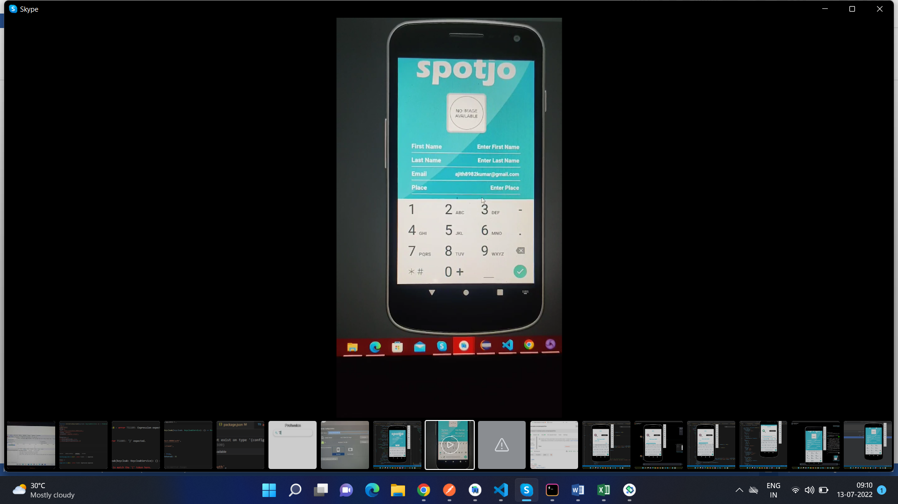

**SOURCE CODE FIX DONE:**

Refer to the screenshots below for the source code changes made.

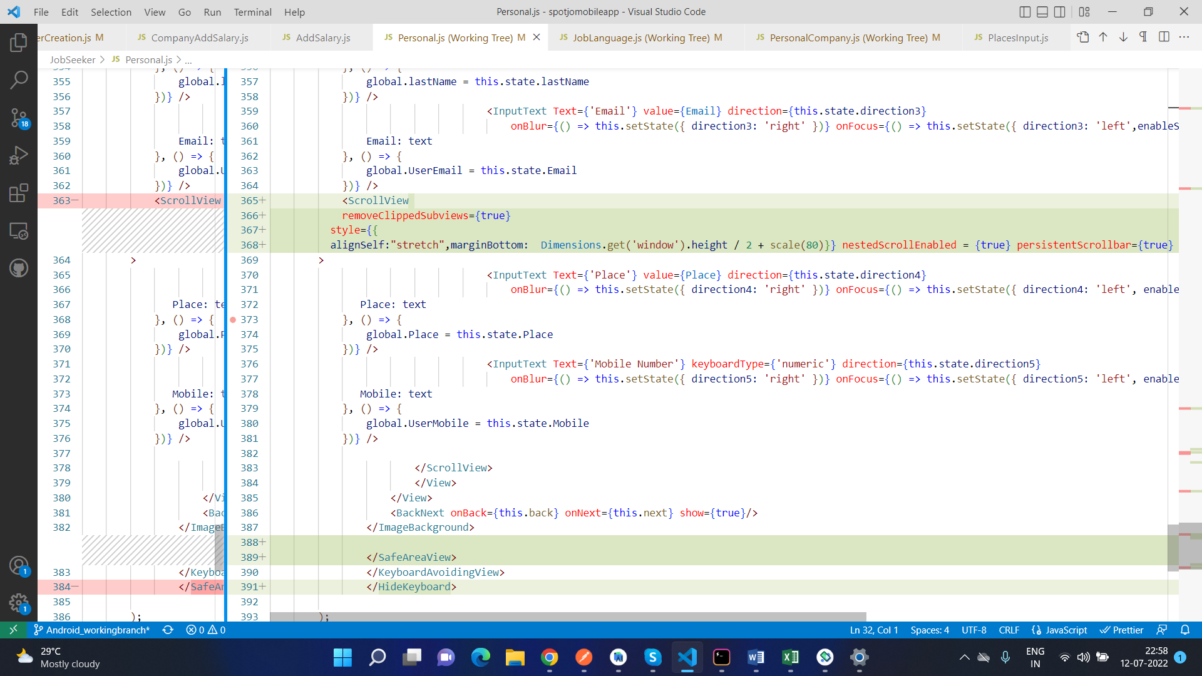

Here is how the page looks like after the code changes:

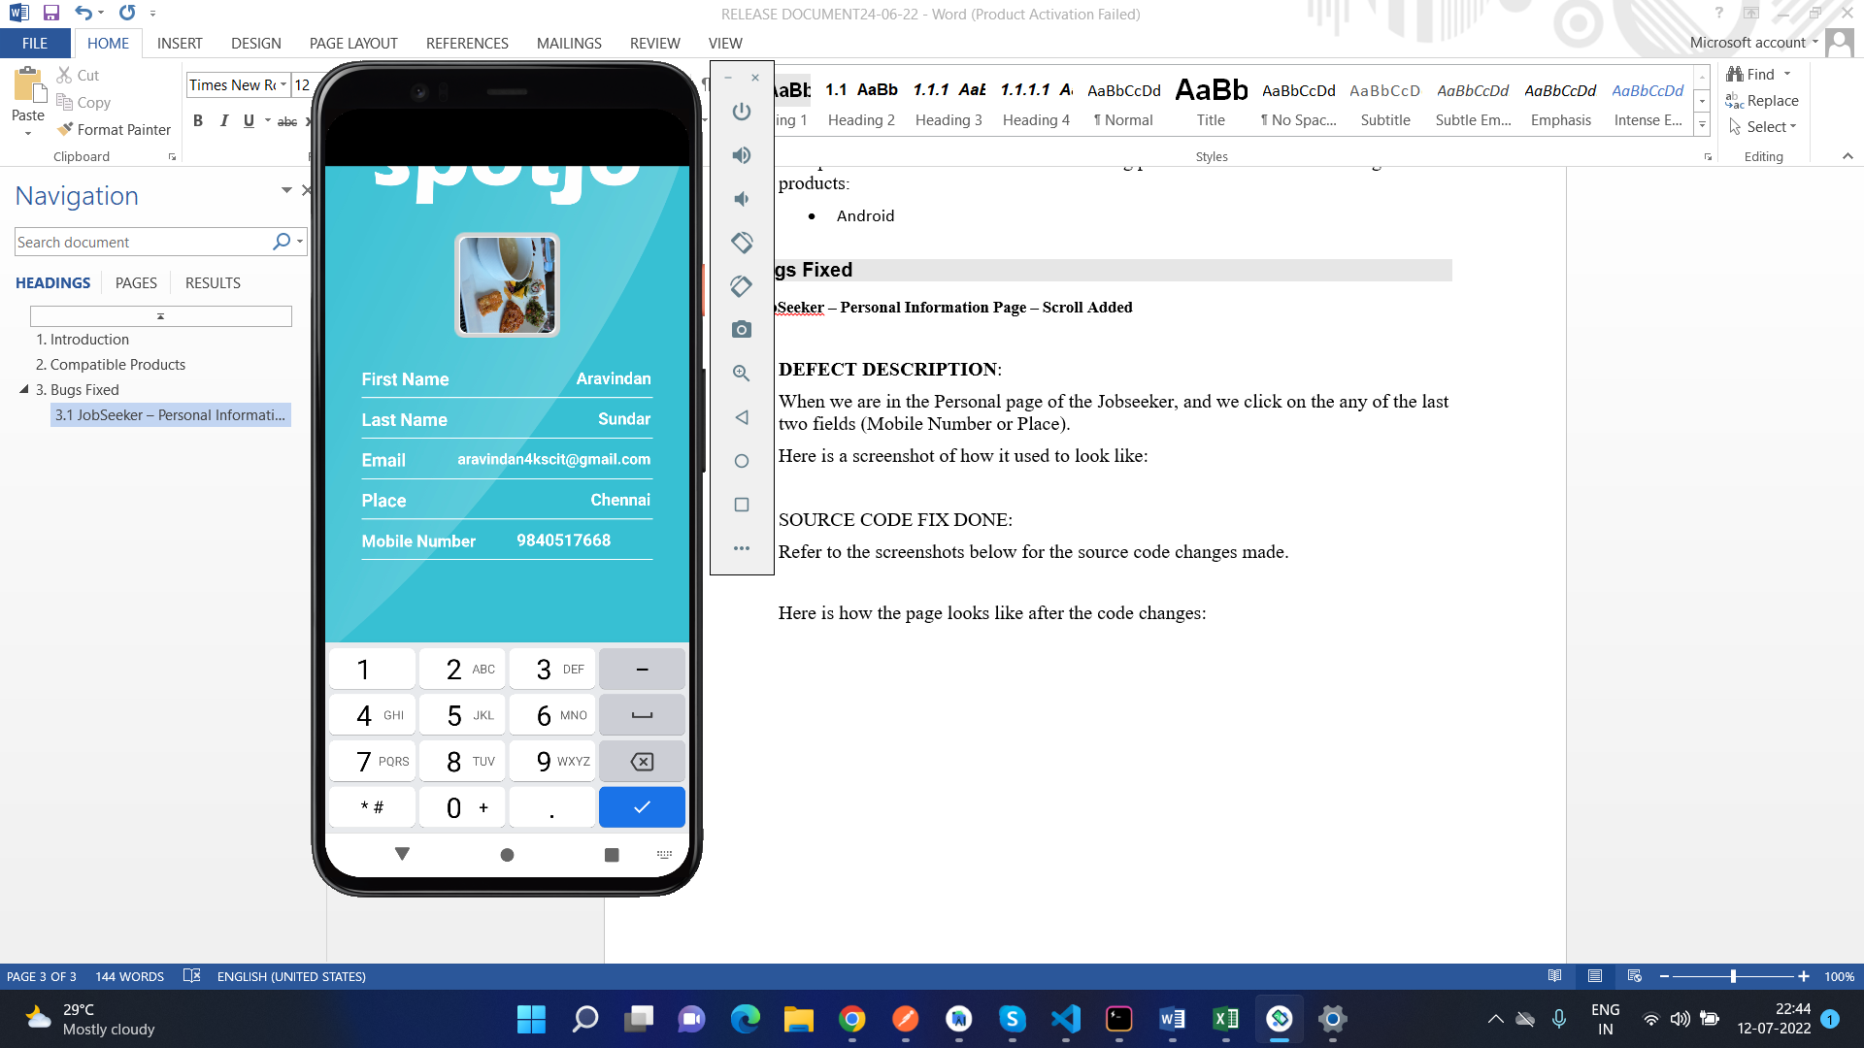

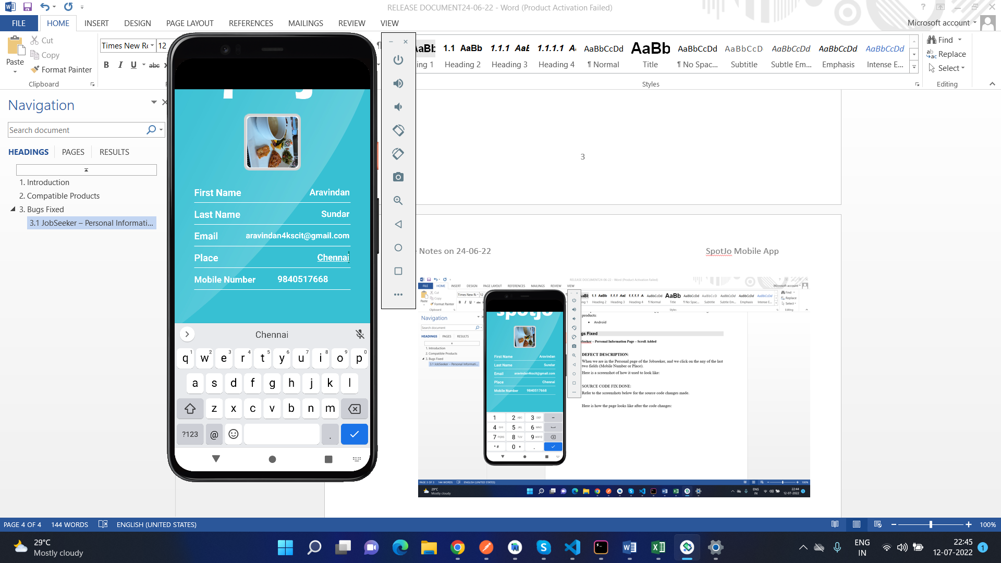

As can be seen in the screenshots, the last 2 fields are not being hidden behind the keyboard and the same 2 fields are being displayed to the user,

## Added functionality so that keyboard will close whenever clicks anywhere on screen

**DEFECT DESCRIPTION:**

In the Jobseeker login, Skills, Language, Work Experience, Personal Information page and in the Company Admin login page, when the keyboard is up, and when we try to close the keyboard by clicking anywhere on the screen, we are not able to do that. So to fix that, we will add a new component called HideKeyboard, which will close the keyboard whenever we click anywhere on the screen.

**SOURCE CODE FIX DONE:**

Login page:

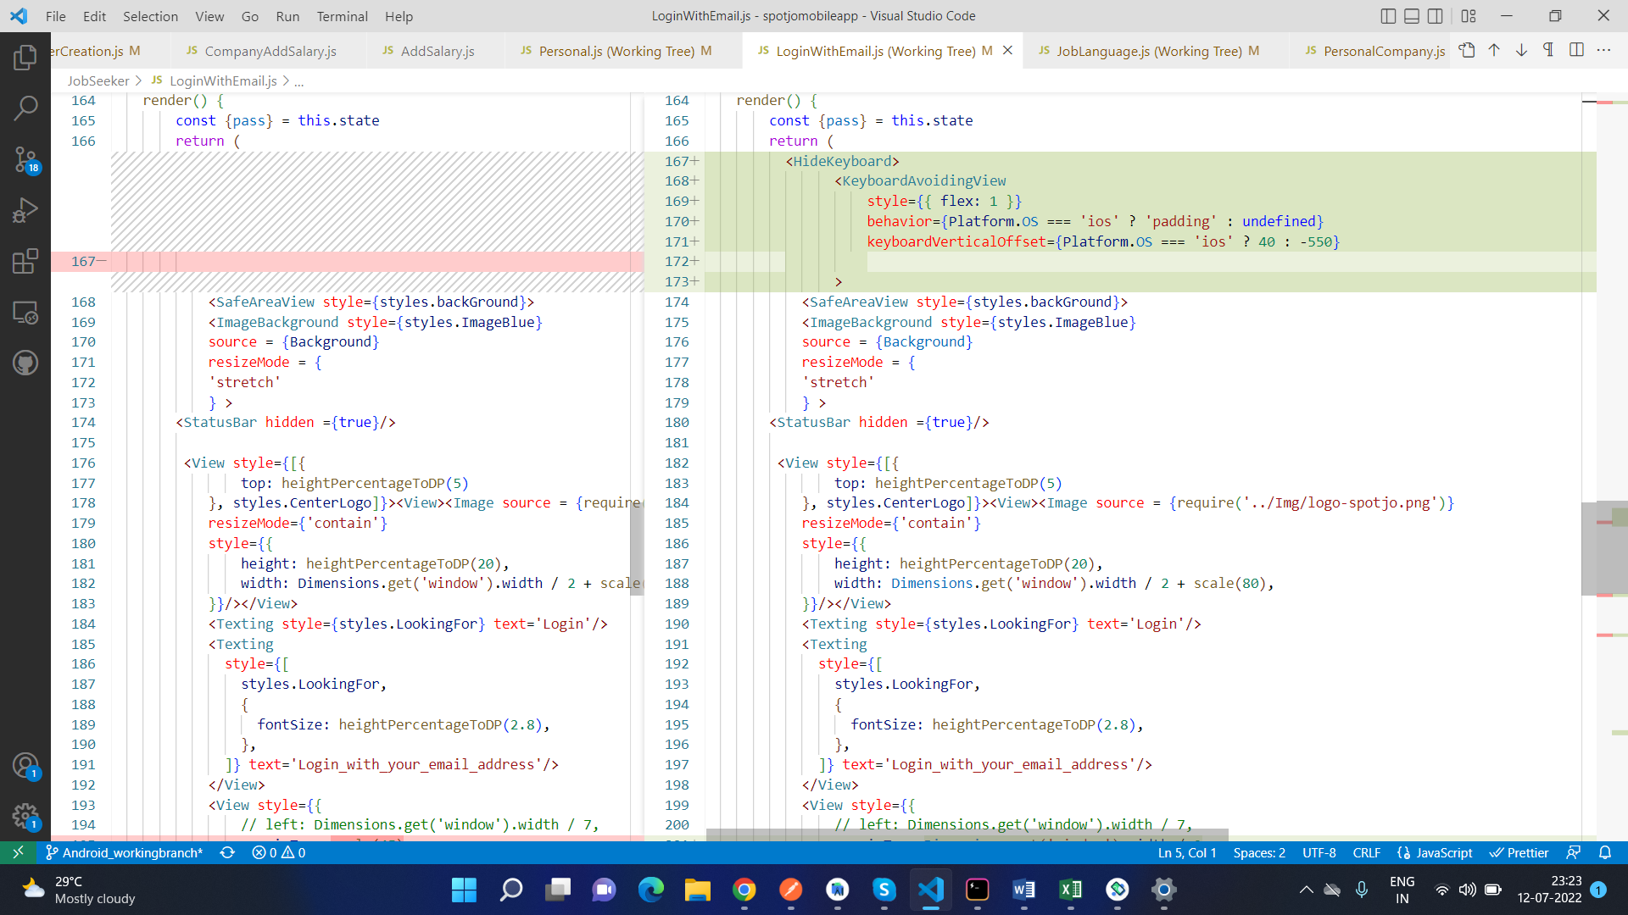

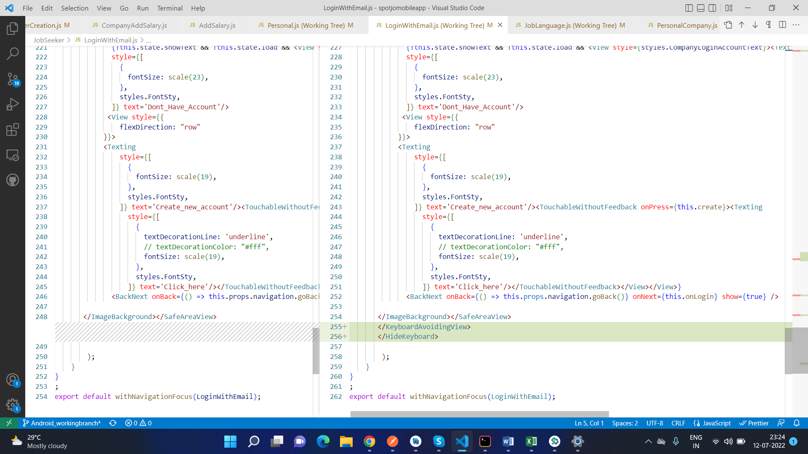

Personal Information:

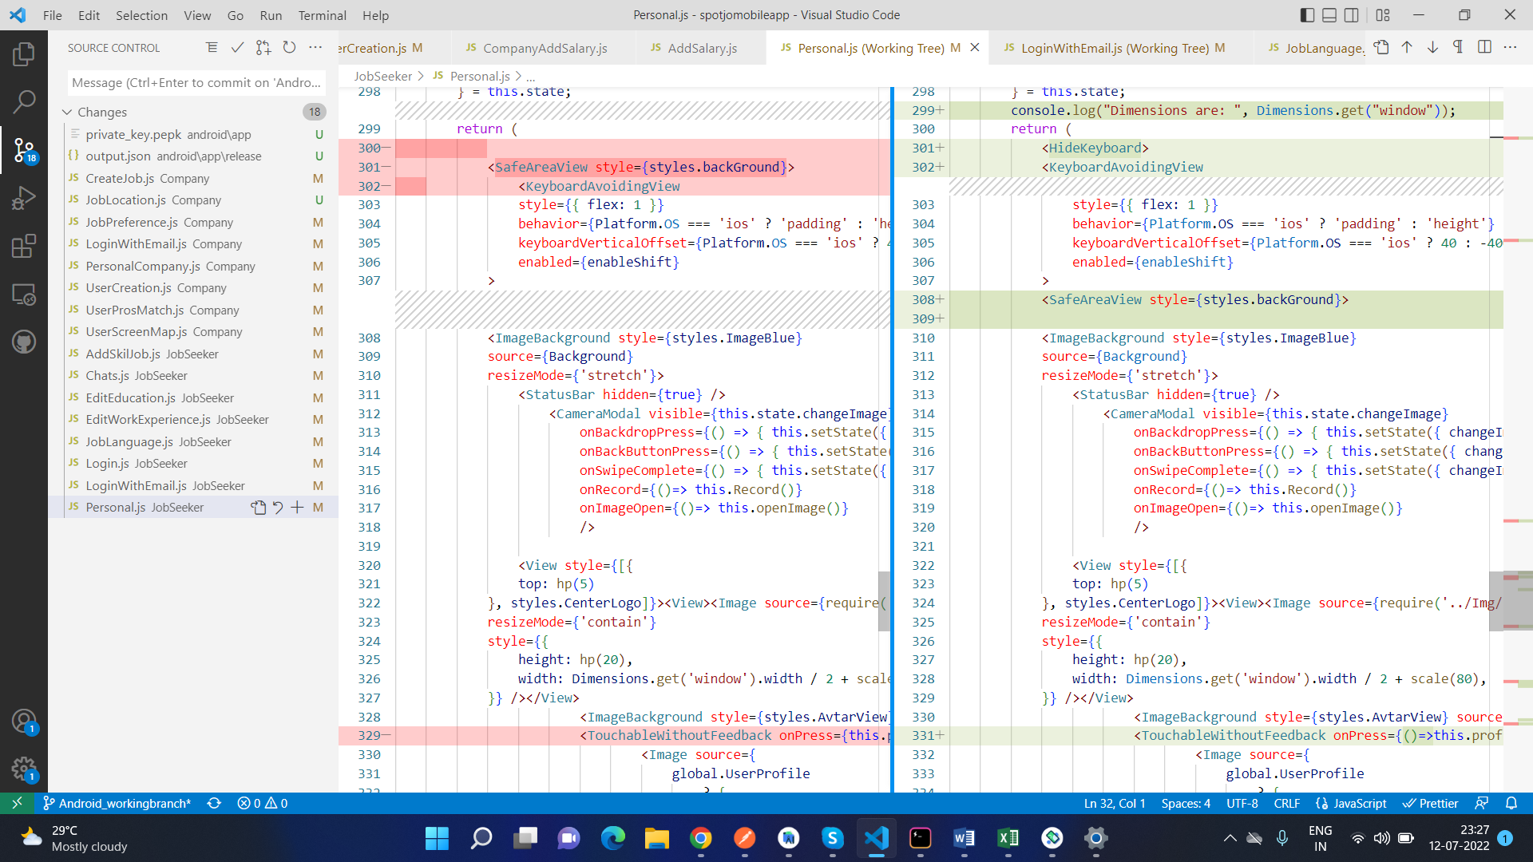

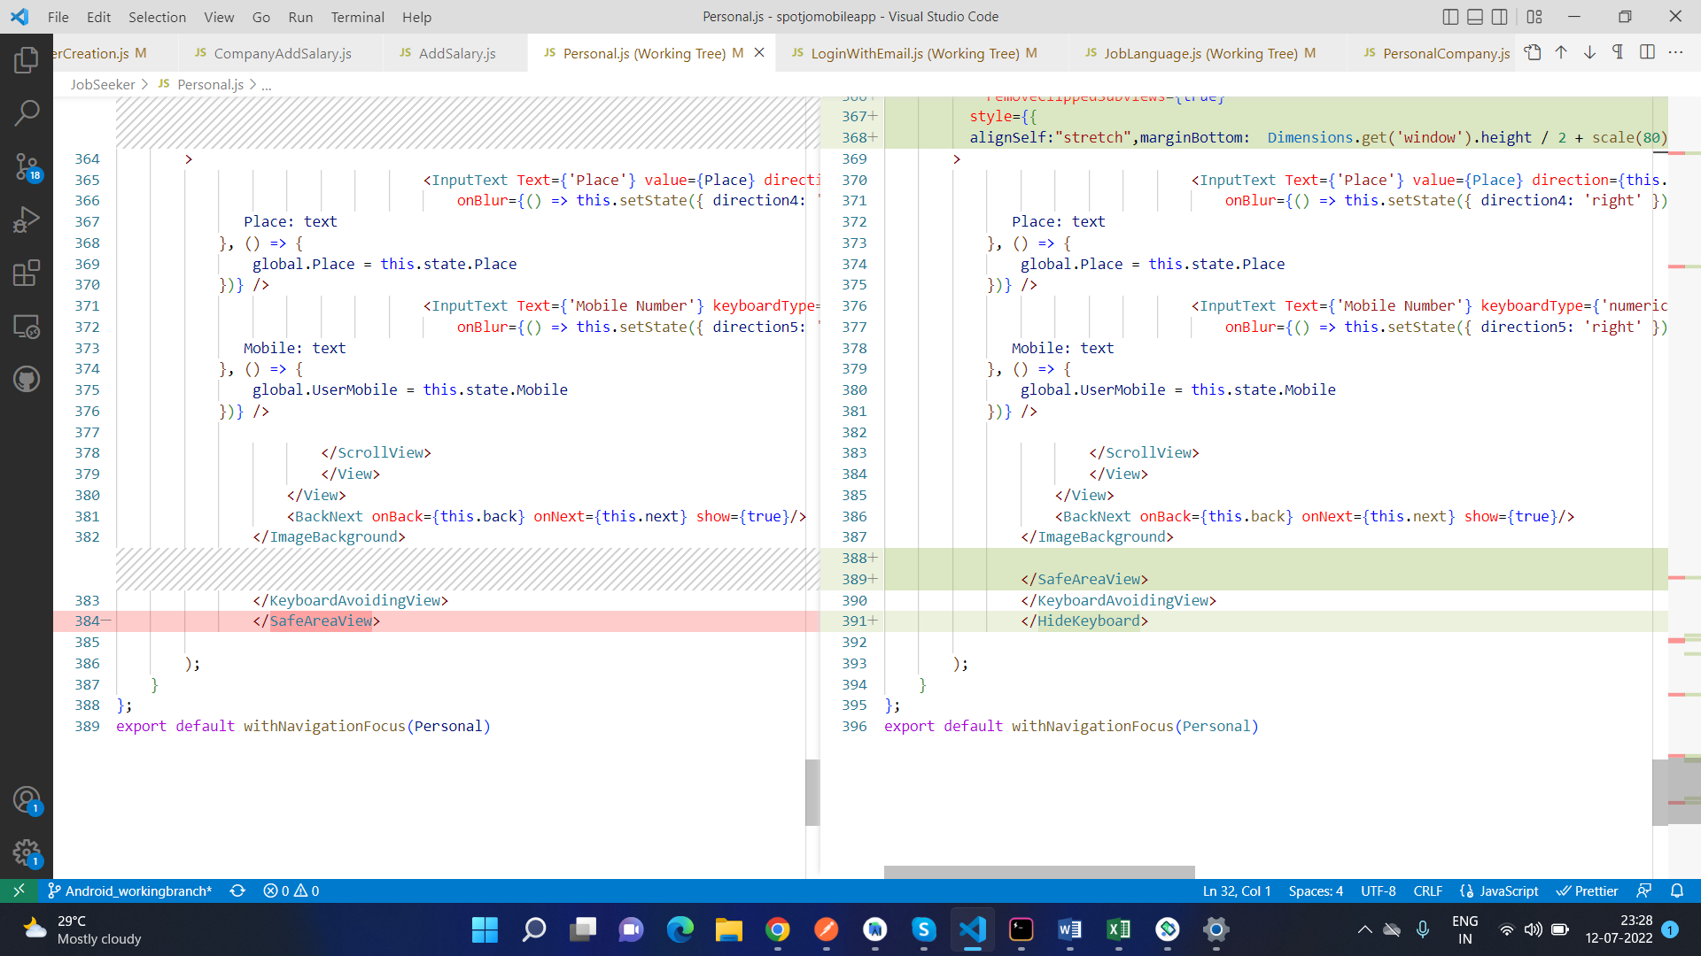

Skills:

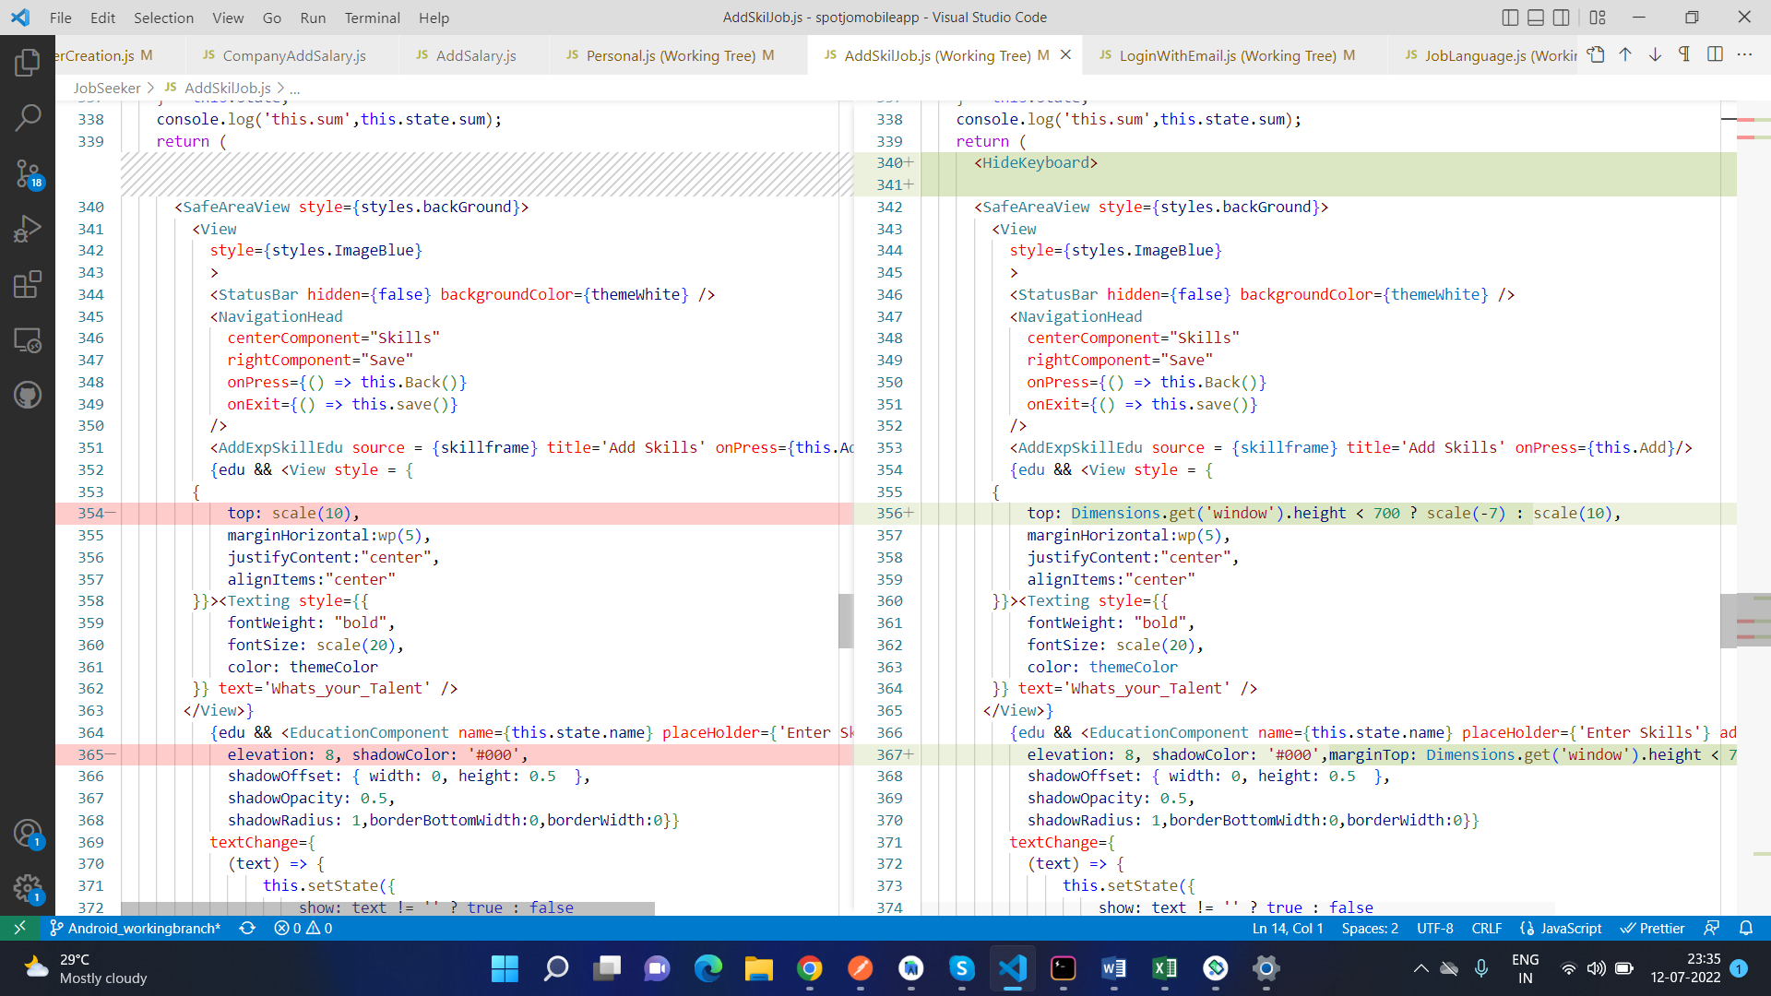

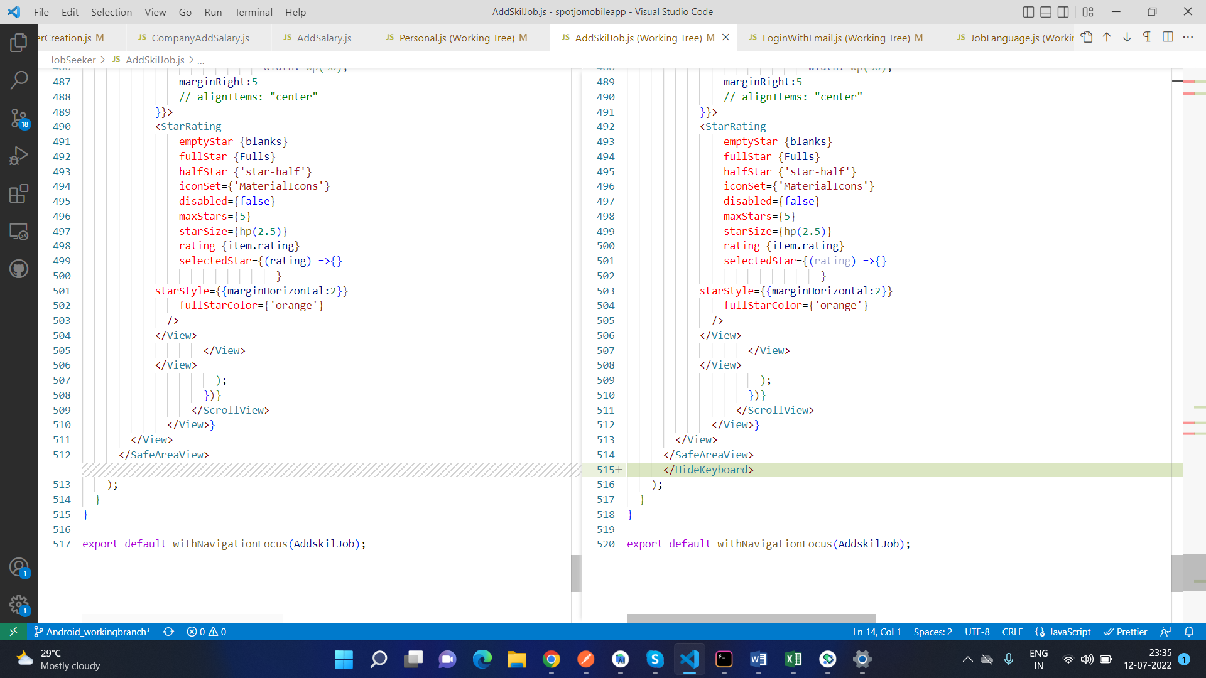

Work Experience:

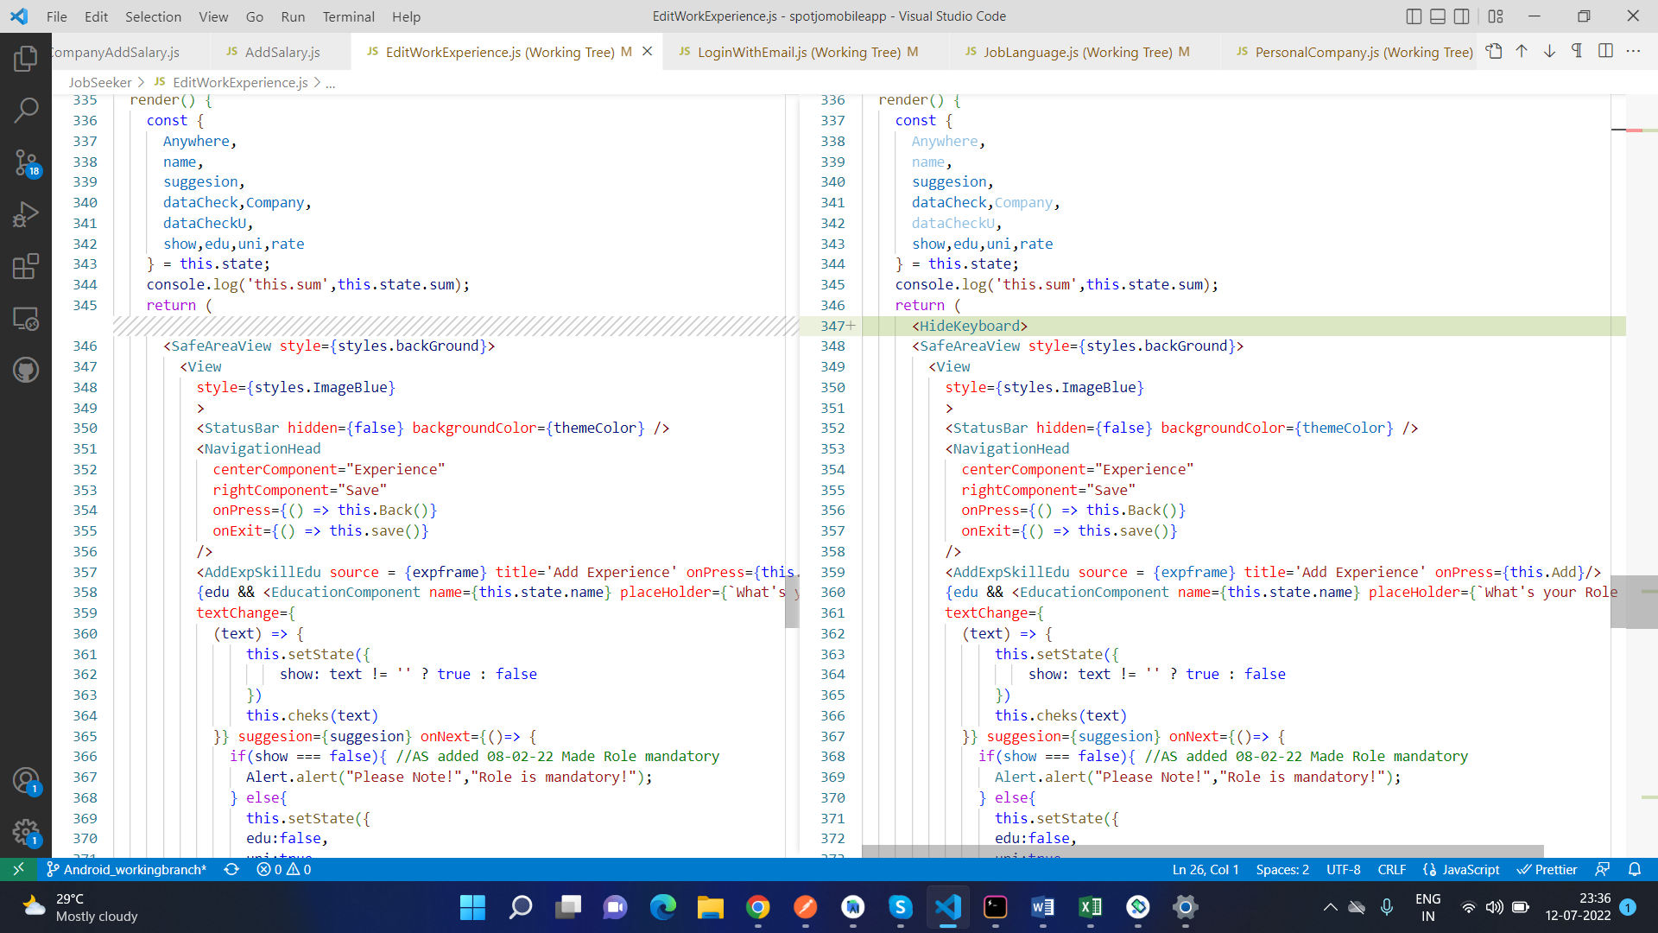

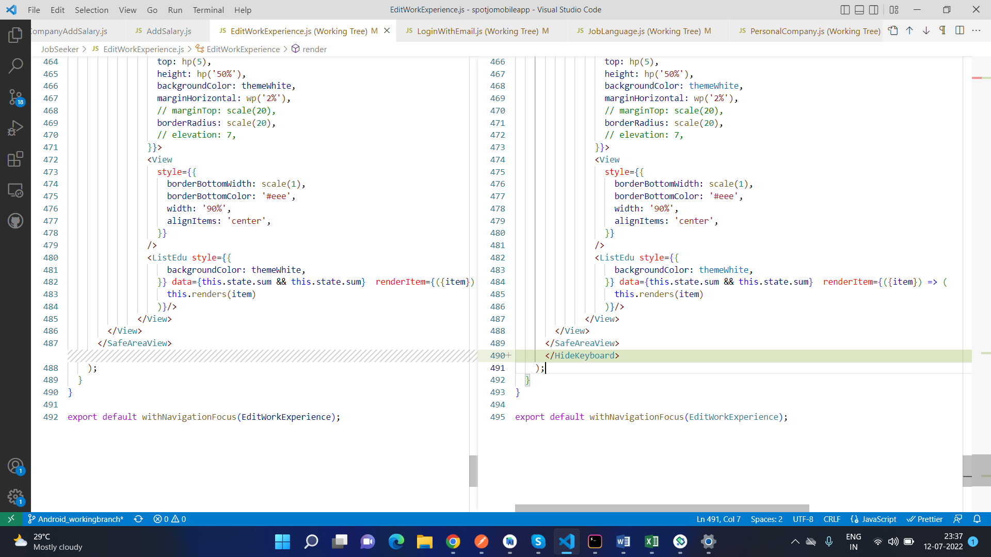

Language:

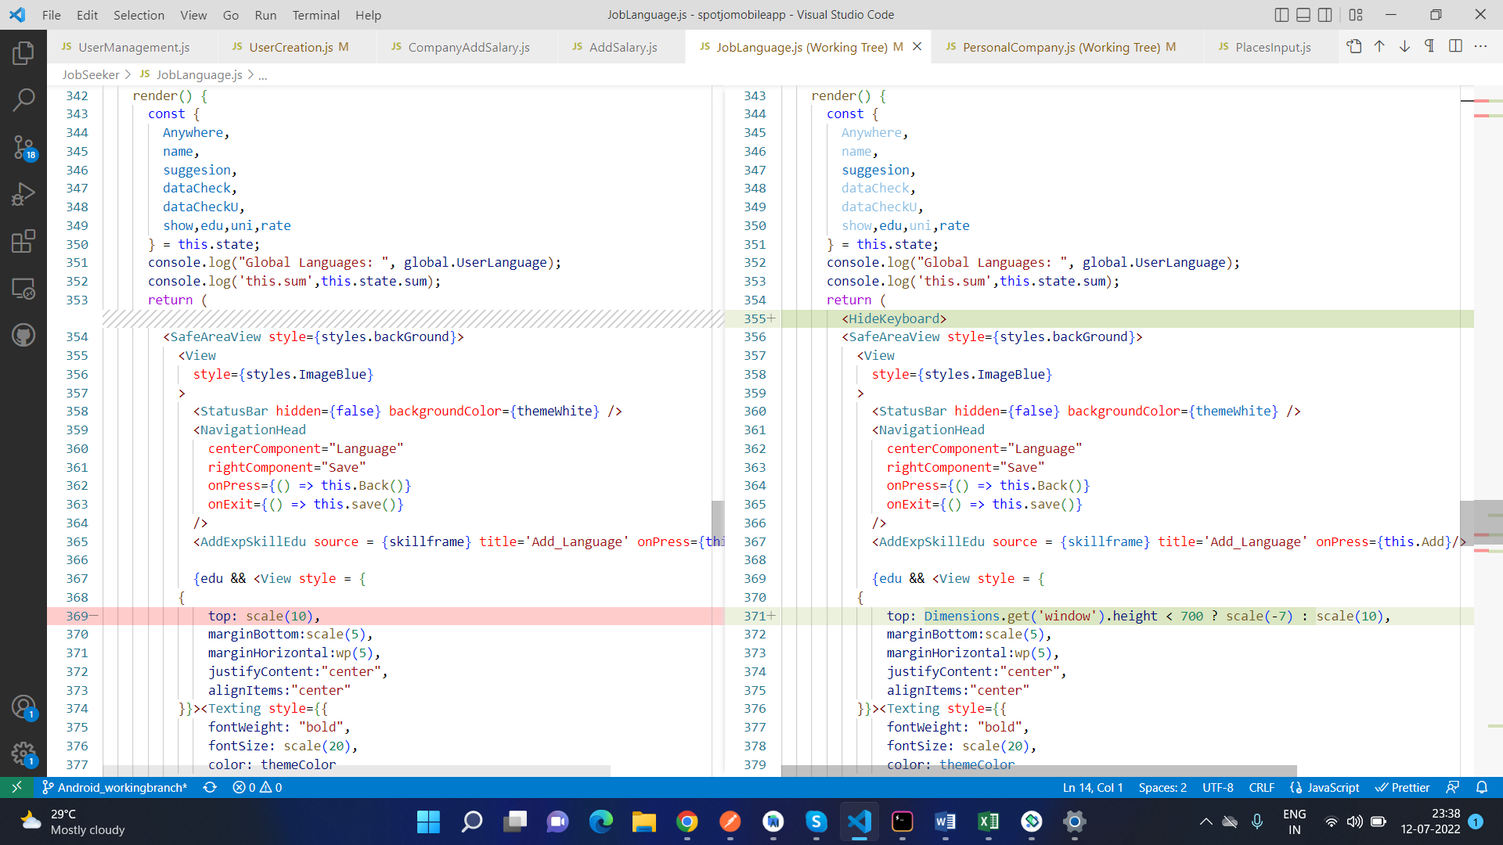

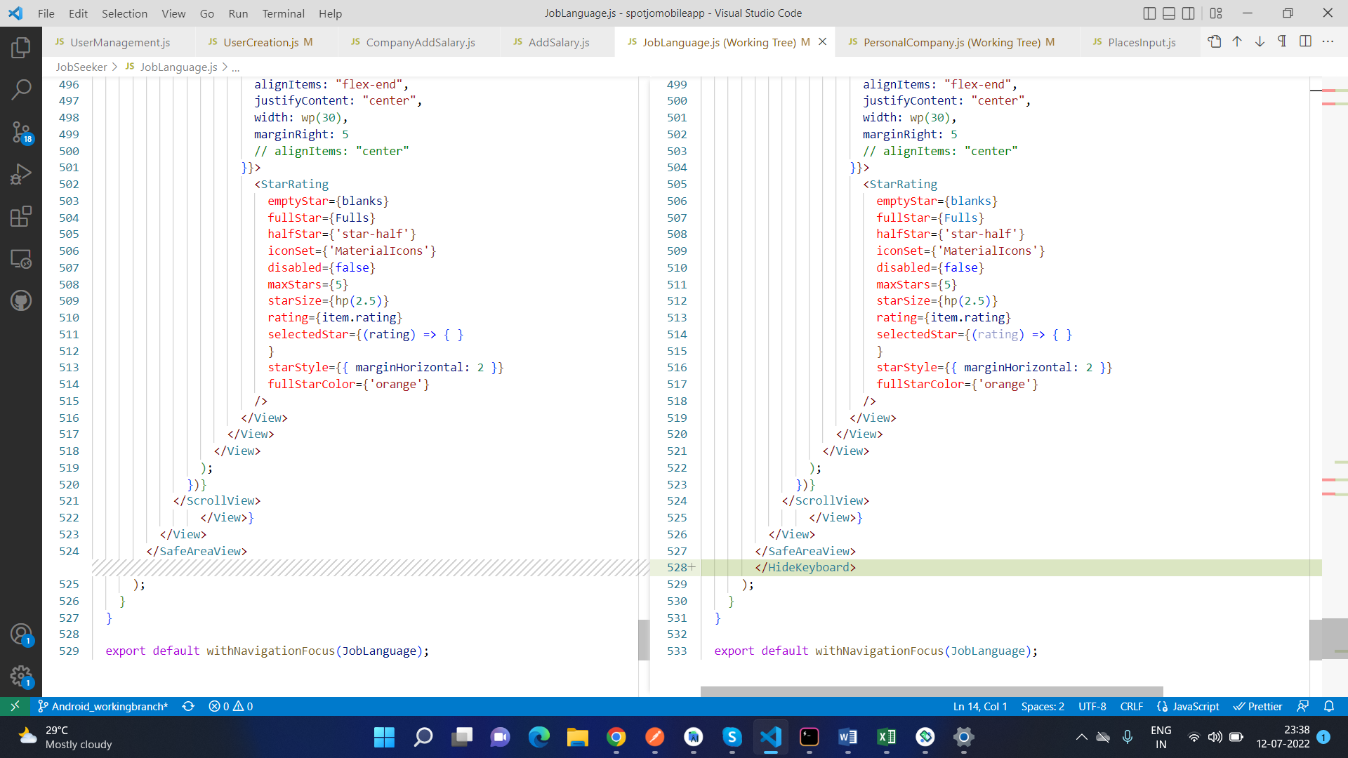

Company Admin Login Page:

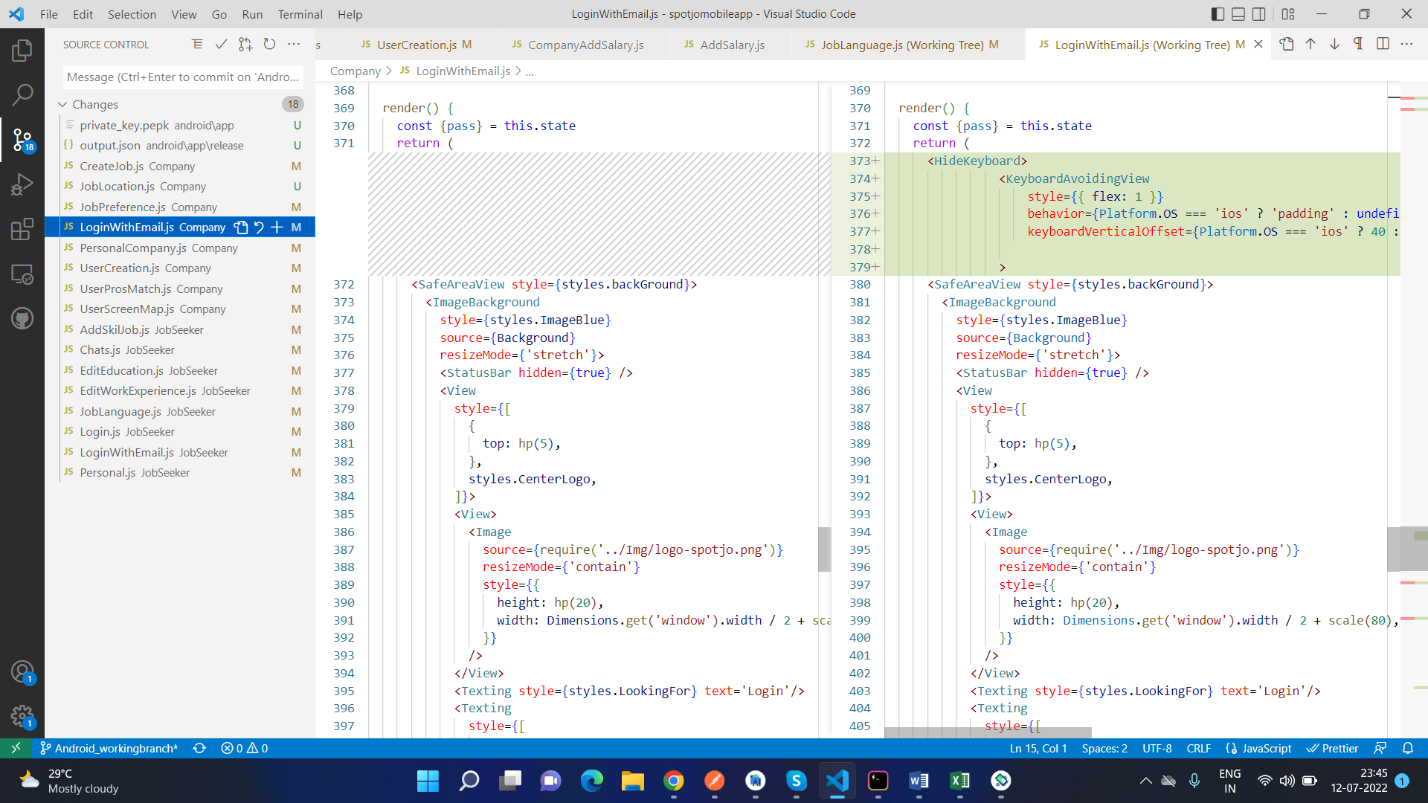

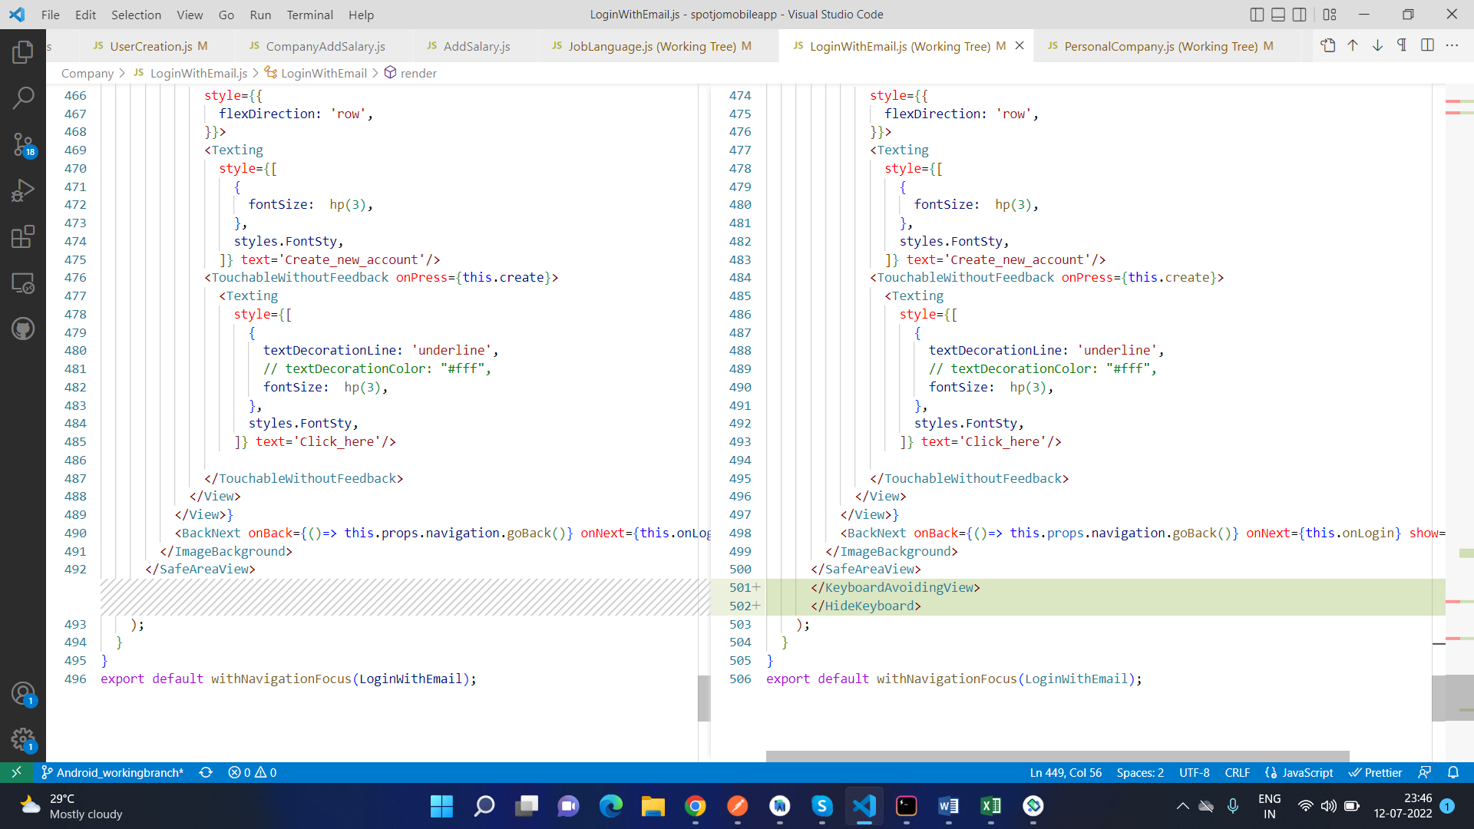

## Adjusting certain pages’ fields to fit on a small size phone

**DEFECT DESCRIPTION:**

When we use our app on a small sized phone (ie the size is less than 5 inches), in some pages the fields, buttons and if applicable, the options on the page are not visible. So to fix that, we use the Dimensions component that is available in the React Native library.

Here are screenshots of how the pages looked like before the code change:

Jobseeker Personal Info page:

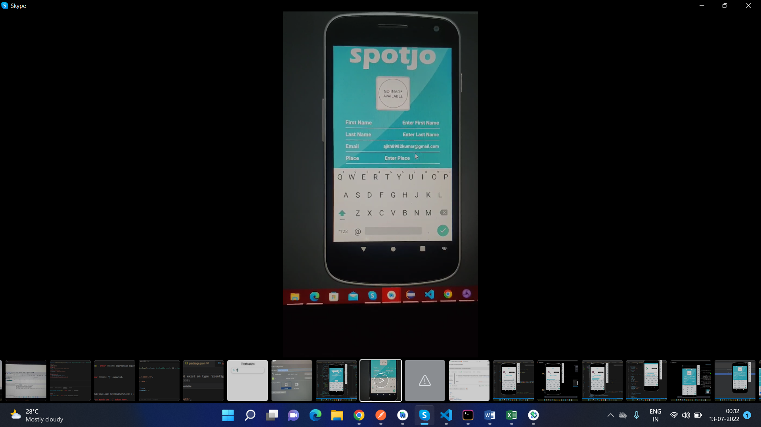

**SOURCE CODE FIX DONE:**

Jobseeker login page:

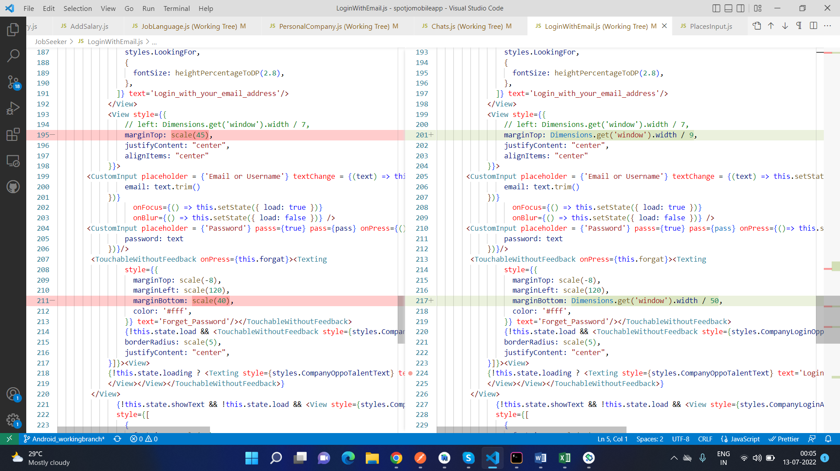

Skills Page:

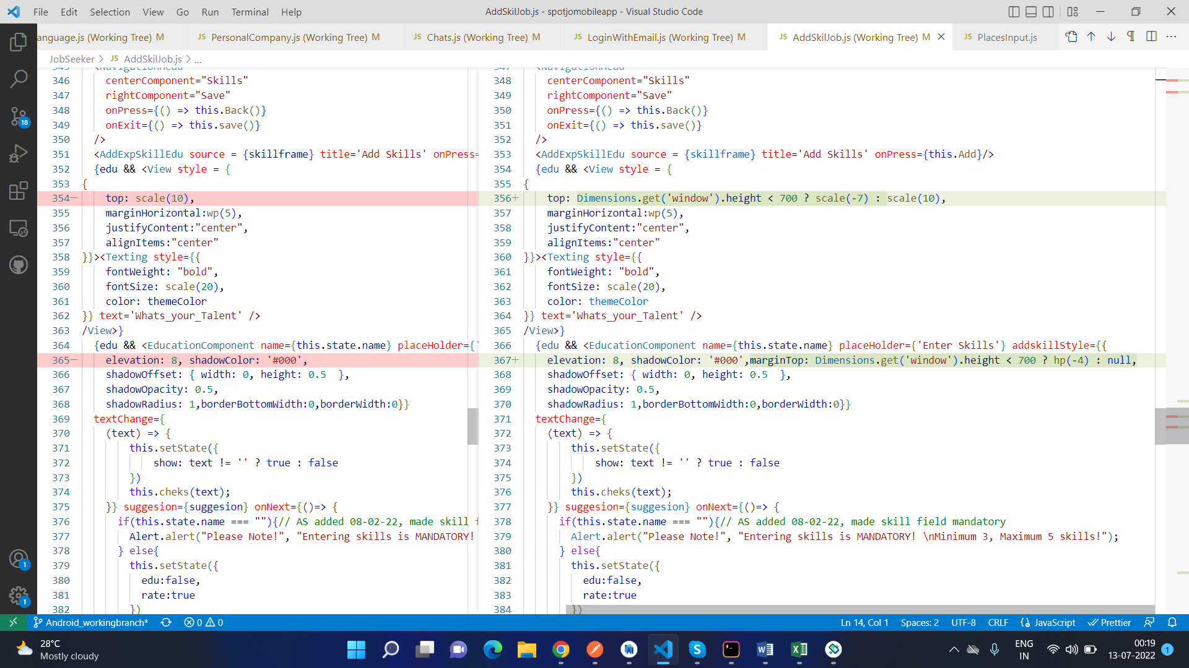

Language Page:

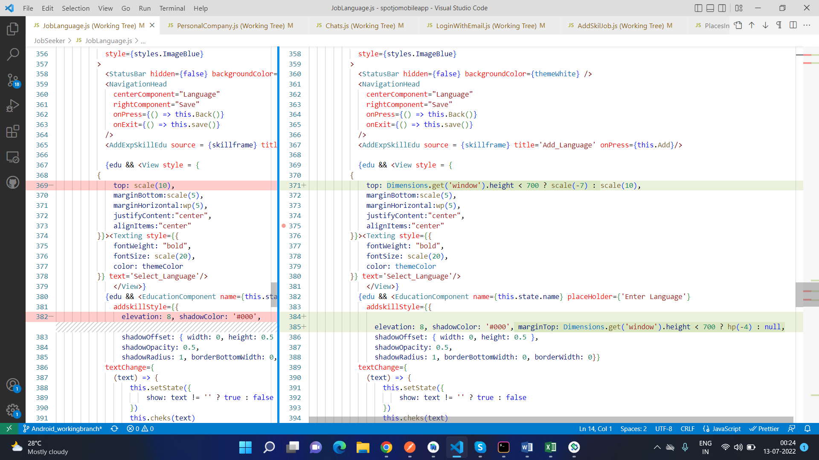

Here is how the page looks like after the code changes:

Login Page:

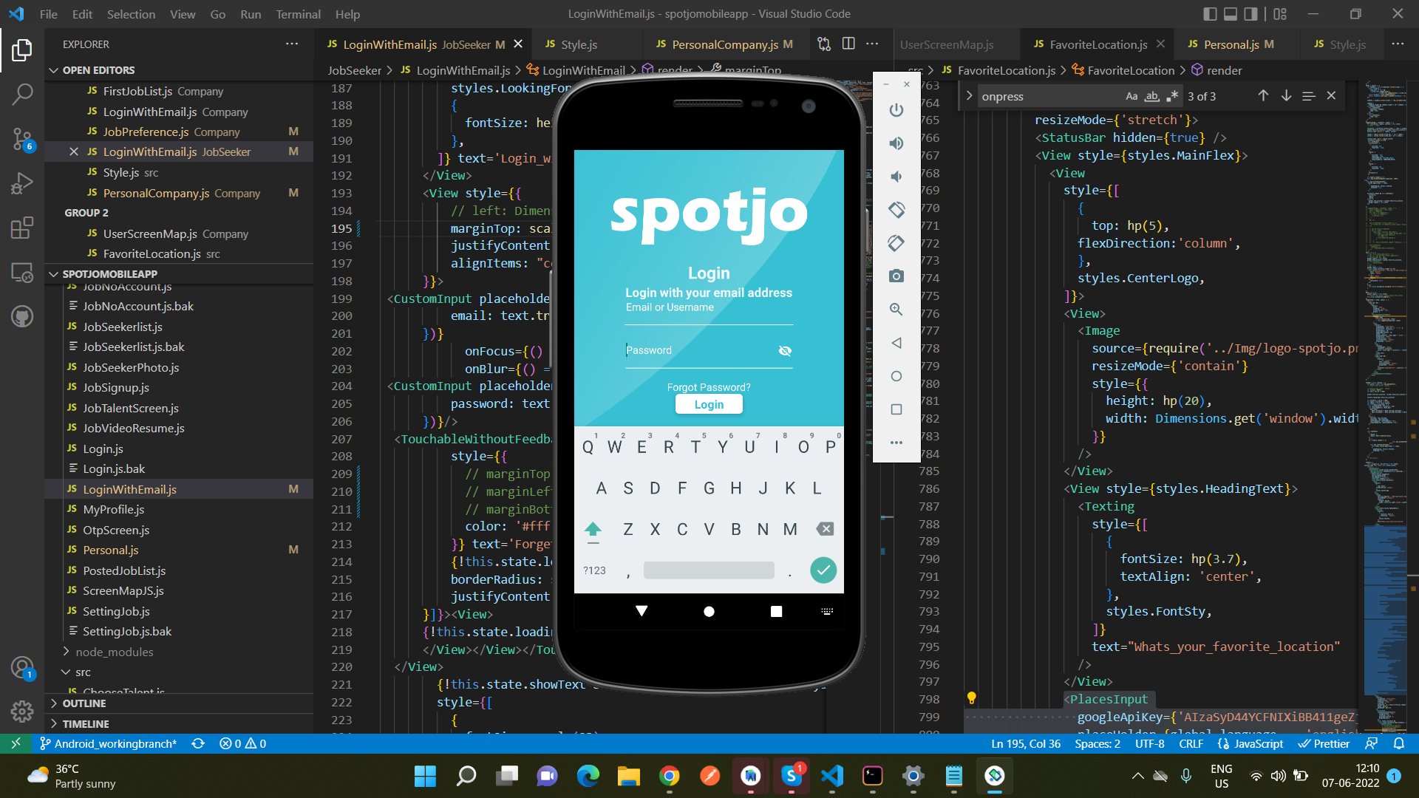

Skills Page:

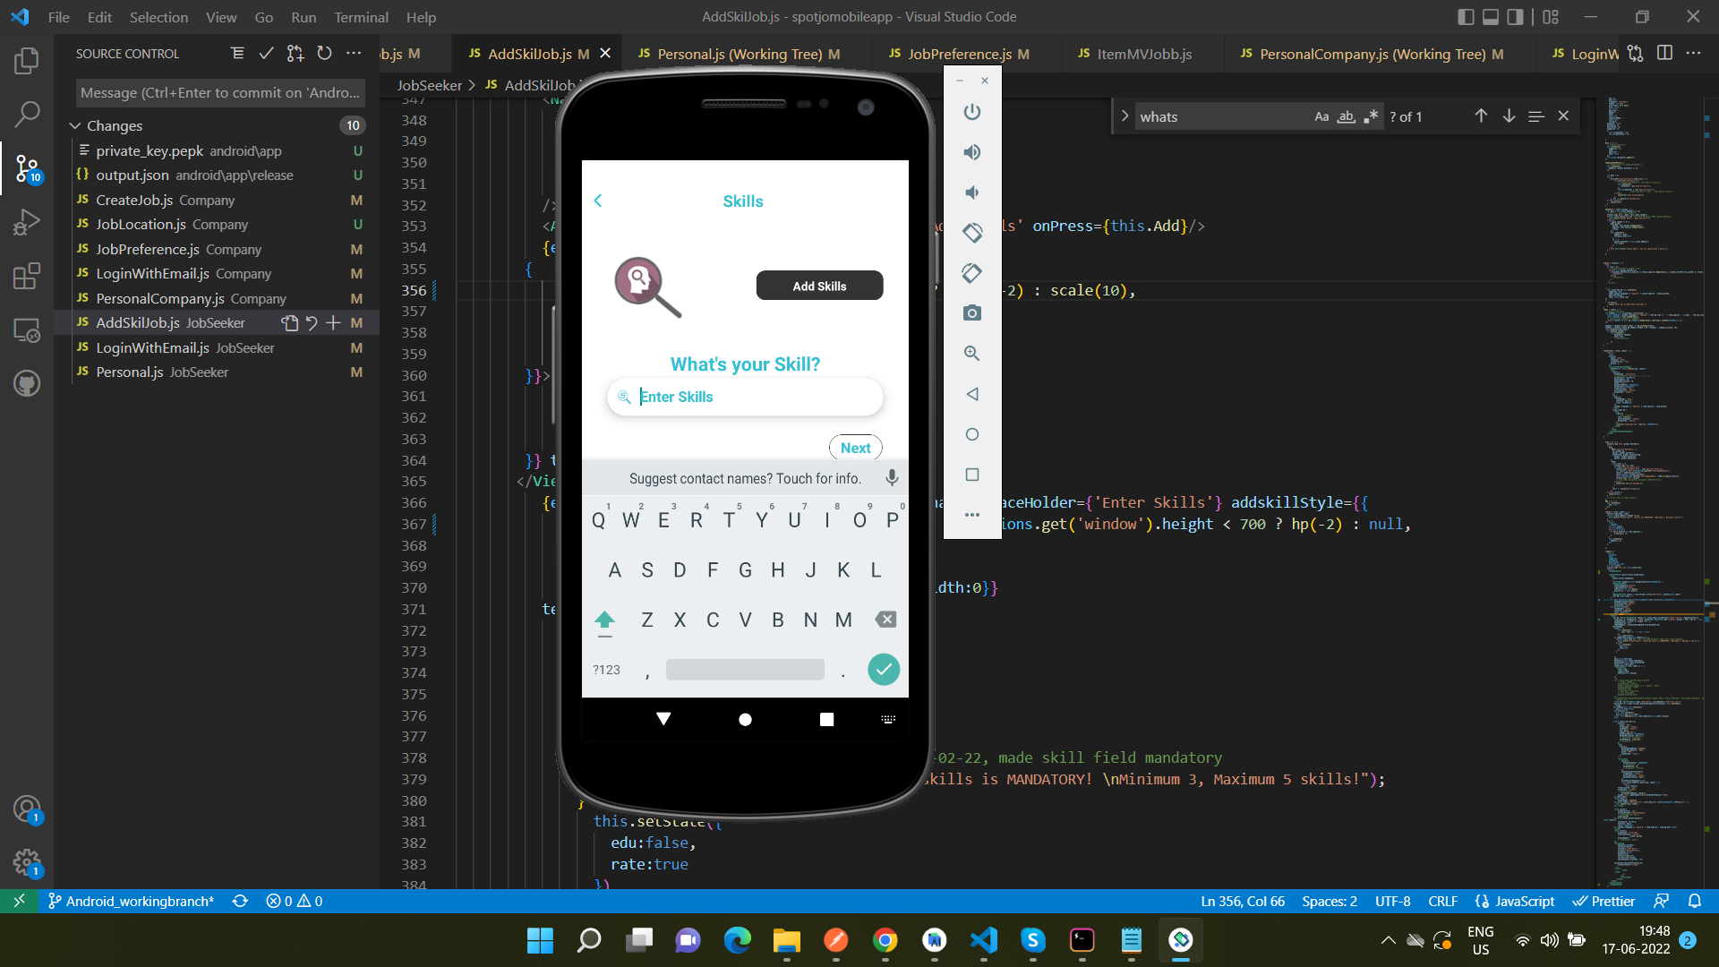

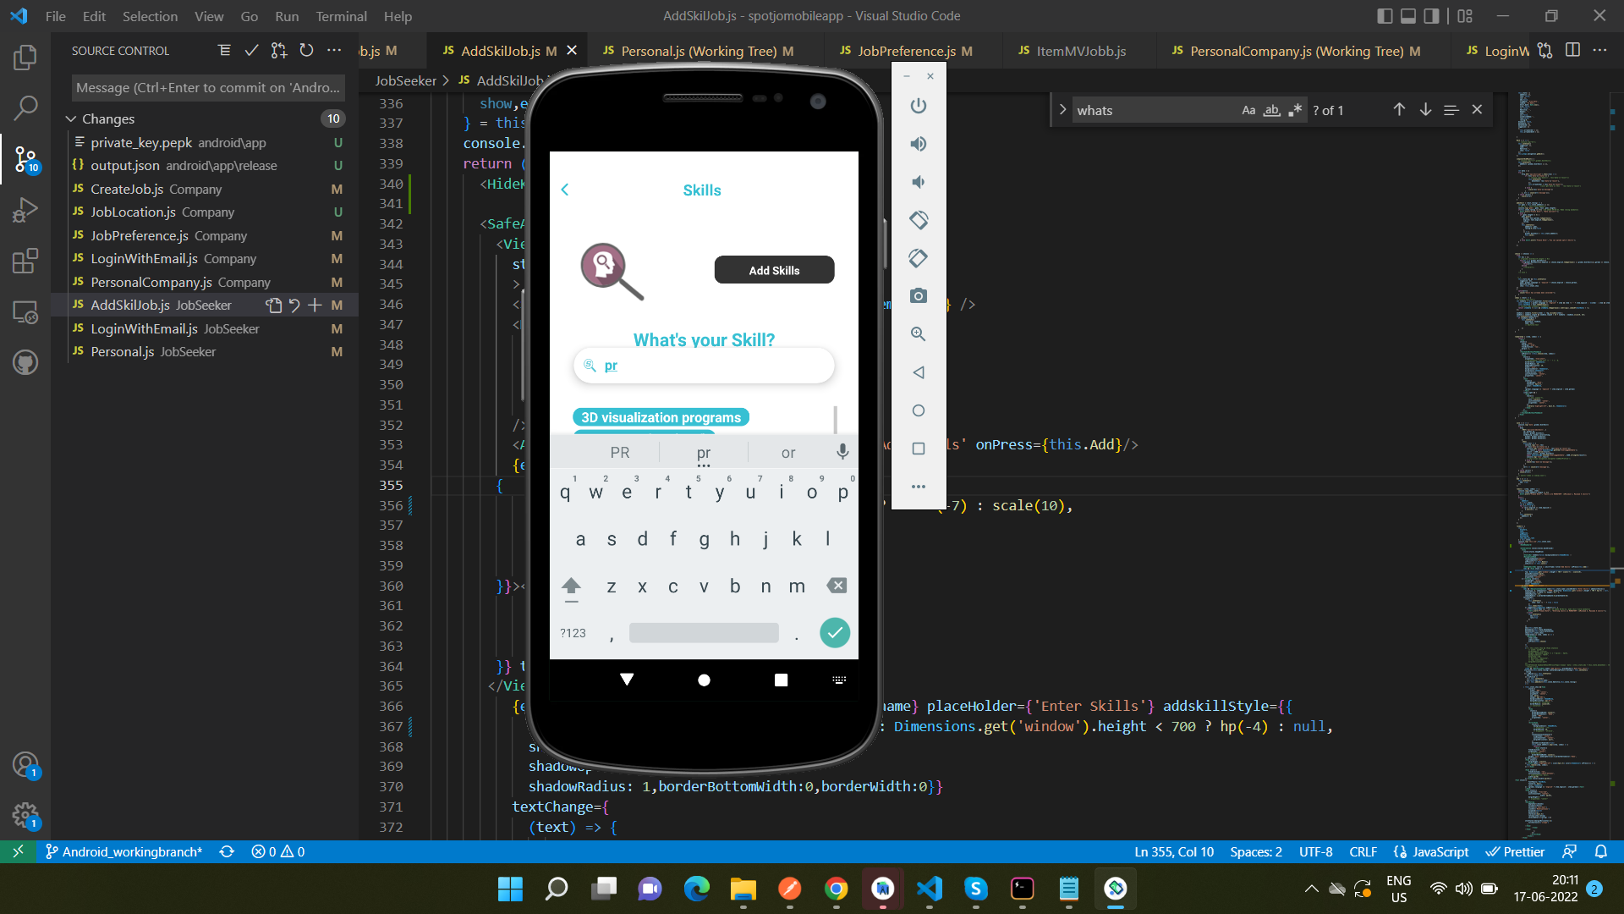

Language Page:

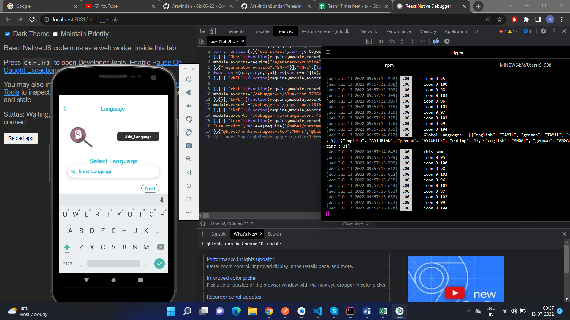

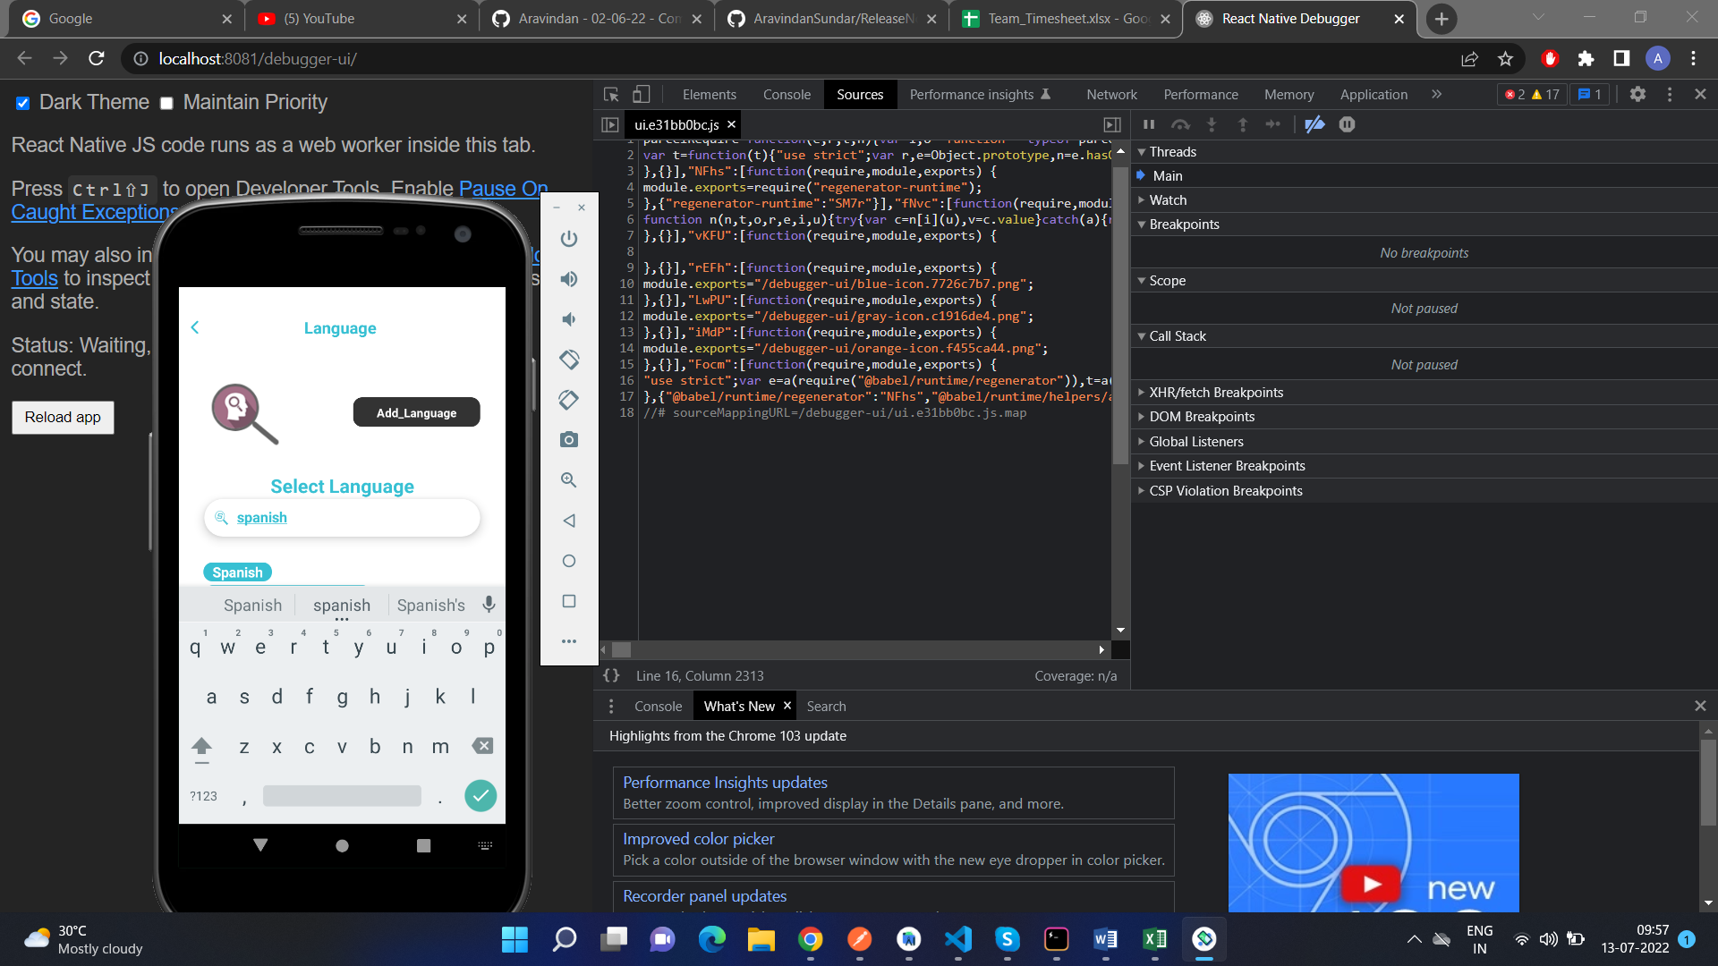

As can be seen in the screenshots, the pages have been modified to make it easier to click on buttons even when we are using on a small sized phone.

## Choosing a Skill only once

**DEFECT DESCRIPTION:**

In Jobseeker, when we are choosing a skill, we are able to choose the same skill once again. So to fix that, we will have to add a condition to the code.

**SOURCE CODE FIX DONE:**

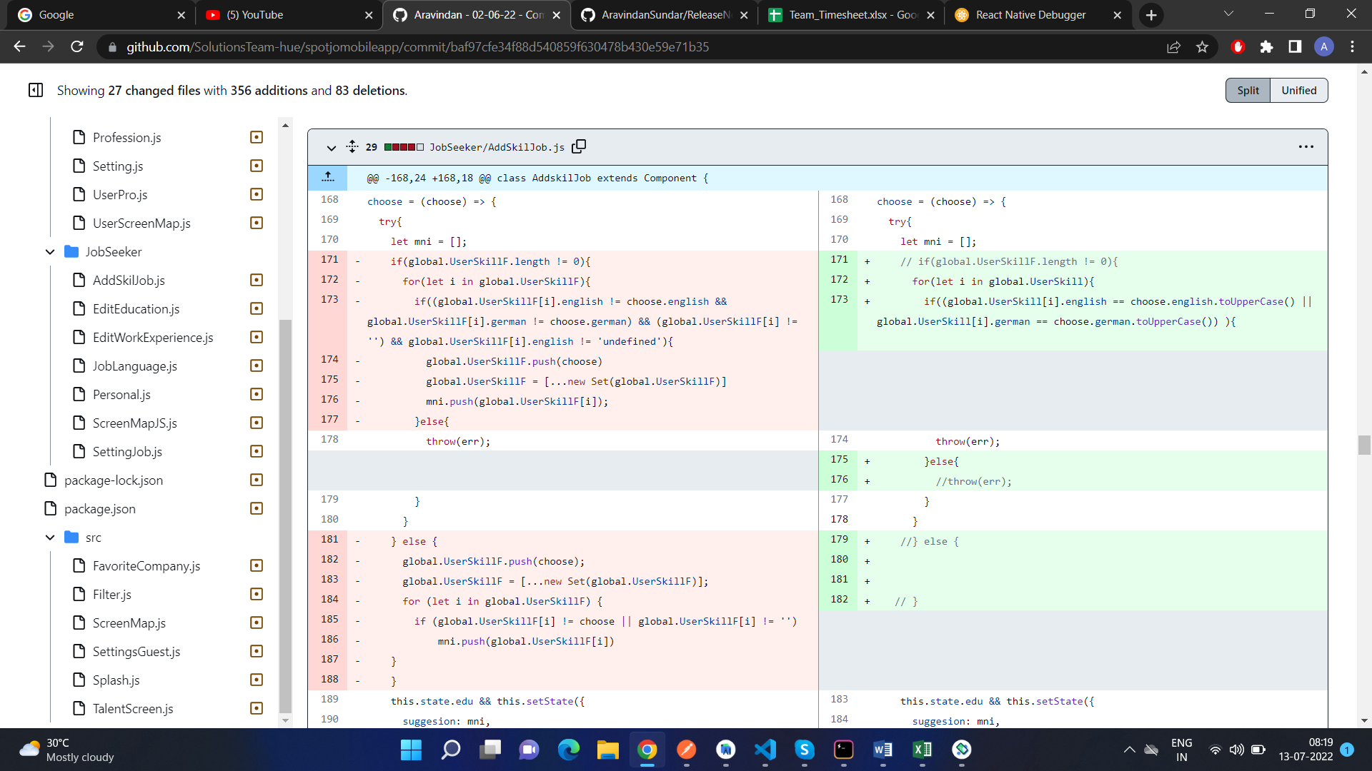

Here are screenshots of how the page looks like after the code change:

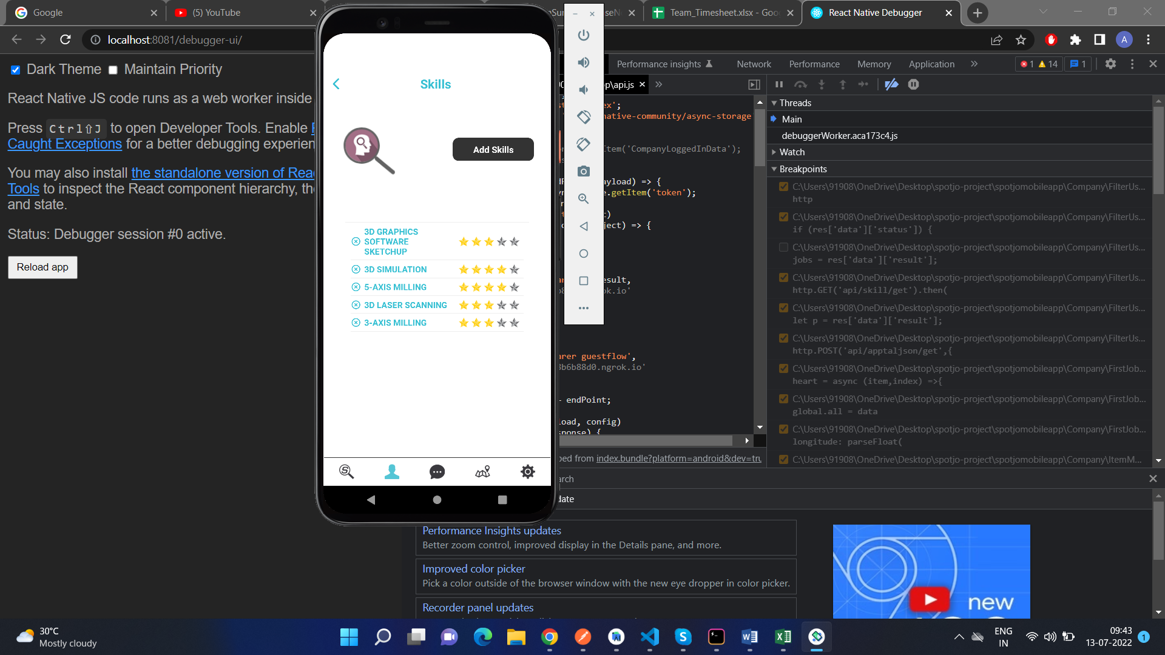

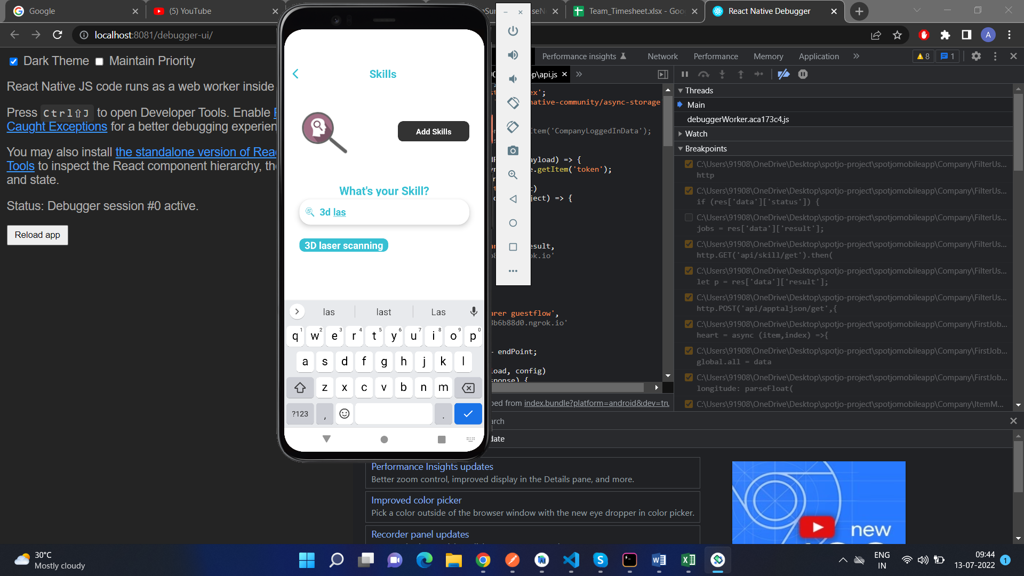

When we try to choose “3D Laser Scanning” in the “Add Skills” option

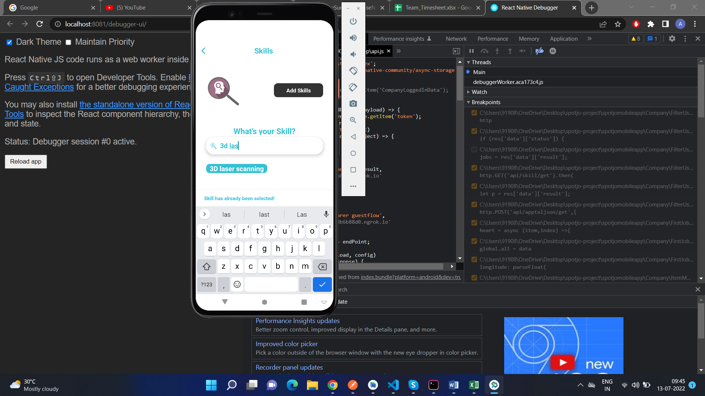

We will get a message that says “Skill has already been selected”

## Company Admin – Job Requirement and Job Description Next Page

**DEFECT DESCRIPTION:**

When we are creating a job and we get to the Job Description and the Job Requirement page, we are unable to close our keyboard without the help of the “Back” button. Not a lot of phones have that “Back” option, so for that defect, we are going to make the “Back” and “Next” button that usually is hidden behind the keyboard, appear on top of the keyboard for these two pages only.

**SOURCE CODE FIX DONE:**

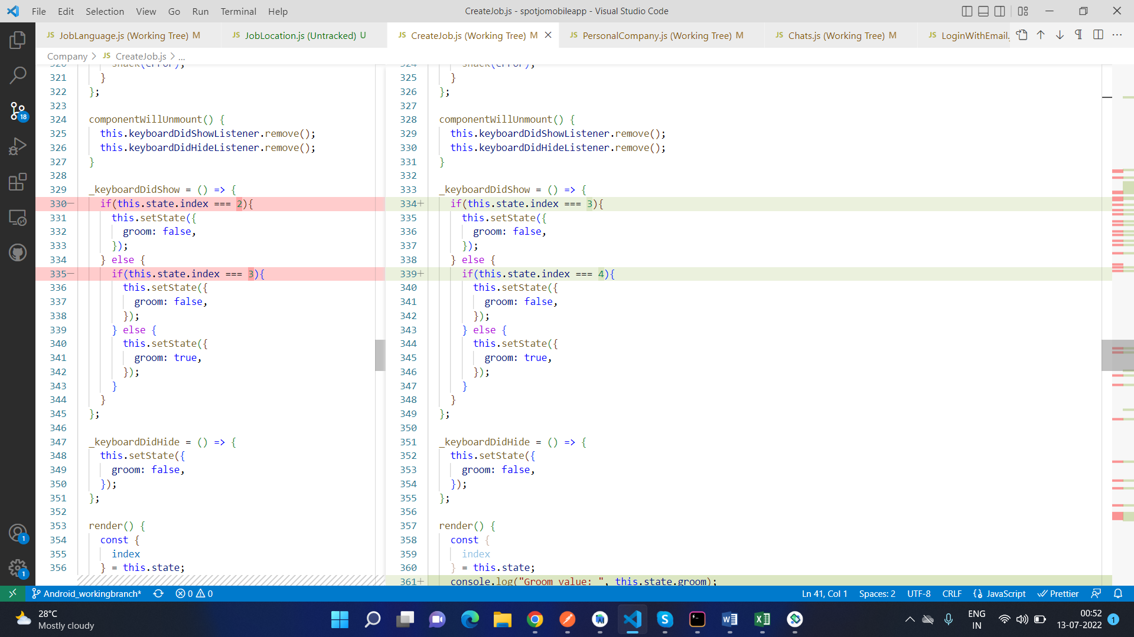

Here are screenshots of how the pages look like after the code change:

Job Description:

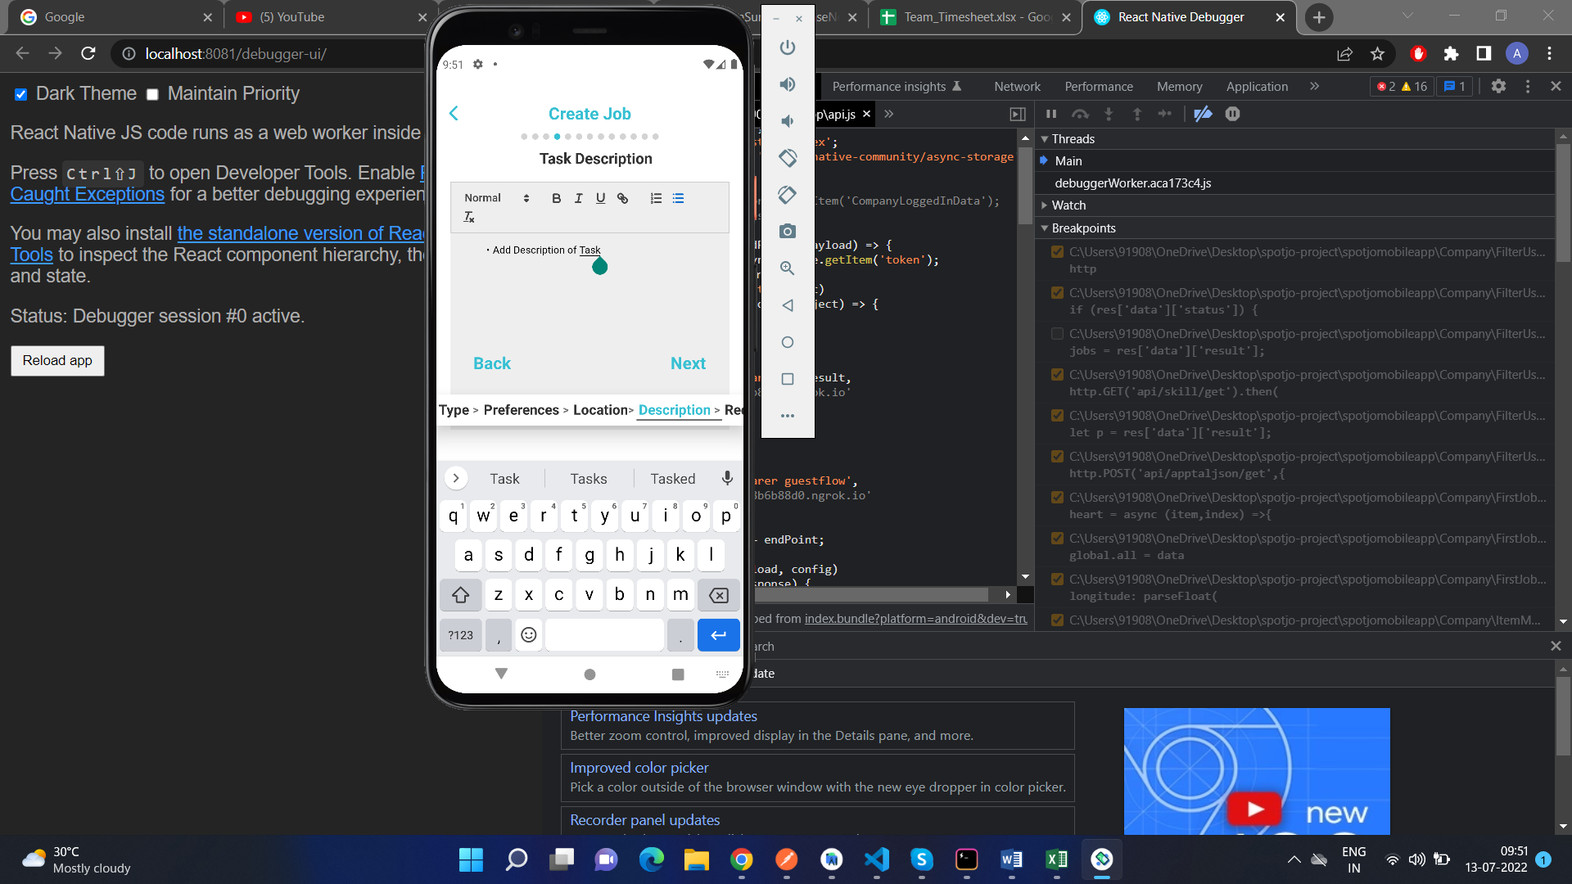

Job Requirement:

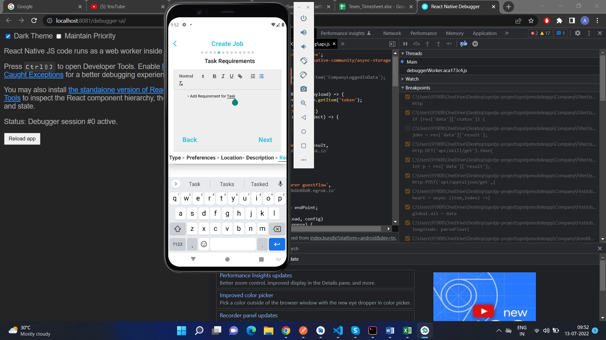

## Job Location Spacing:

**DEFECT DESCRIPTION:**

In the Job Location page, when we enter multiple places, the selected options looks cramped and to fix that, we must add some spacing between the input field and the map.

Here is how the page looked like before the code change:

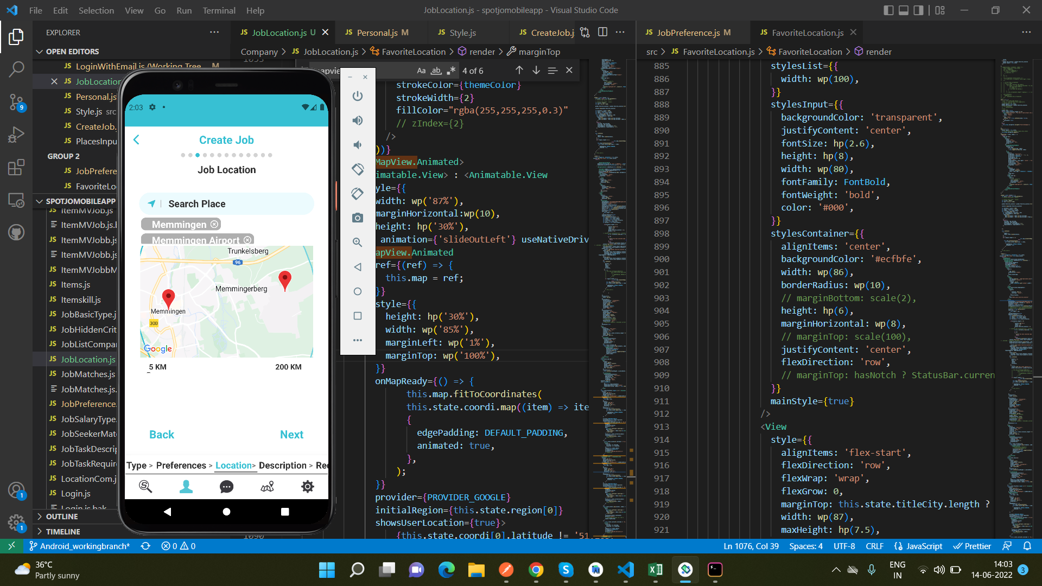

**SOURCE CODE FIX DONE:**

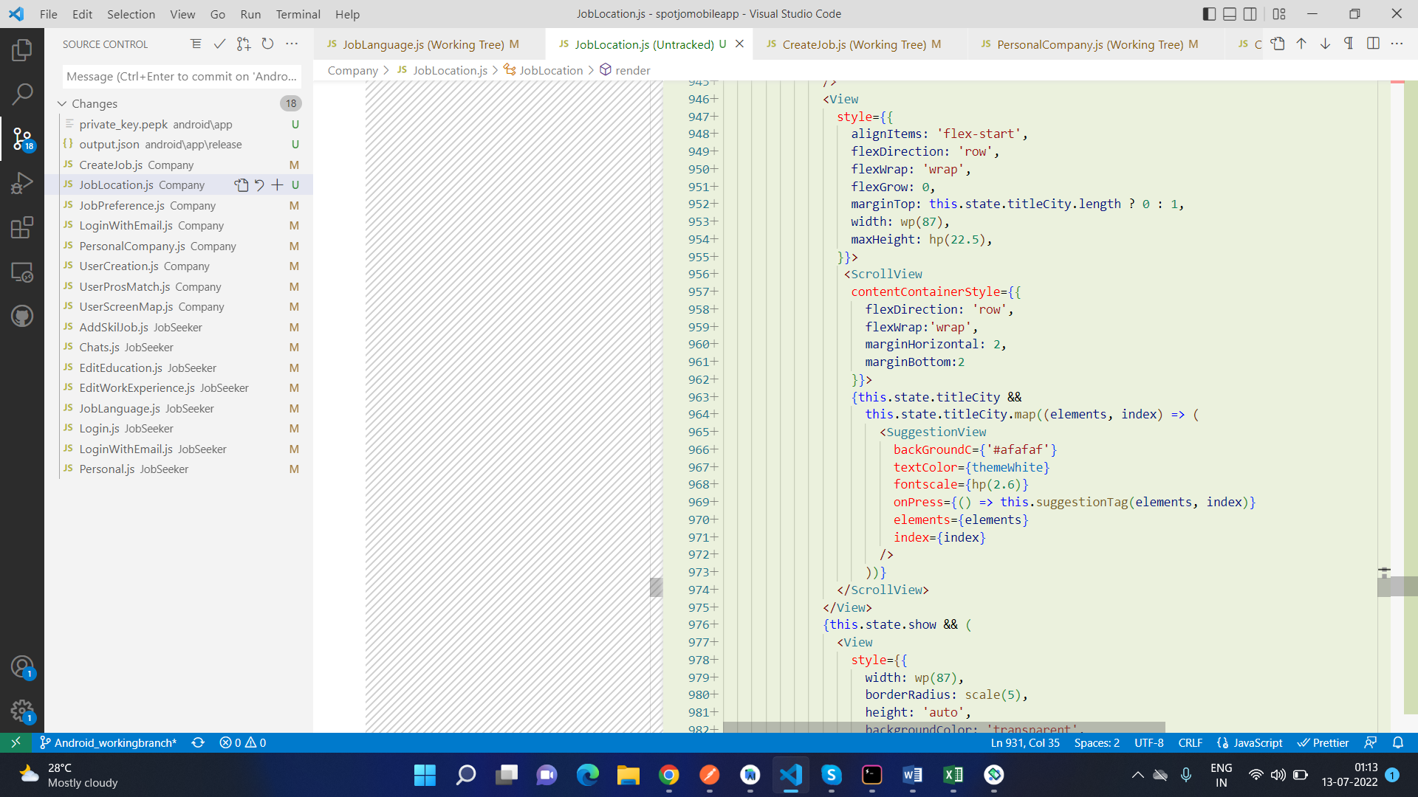

Here’s how the page looks after the code change:

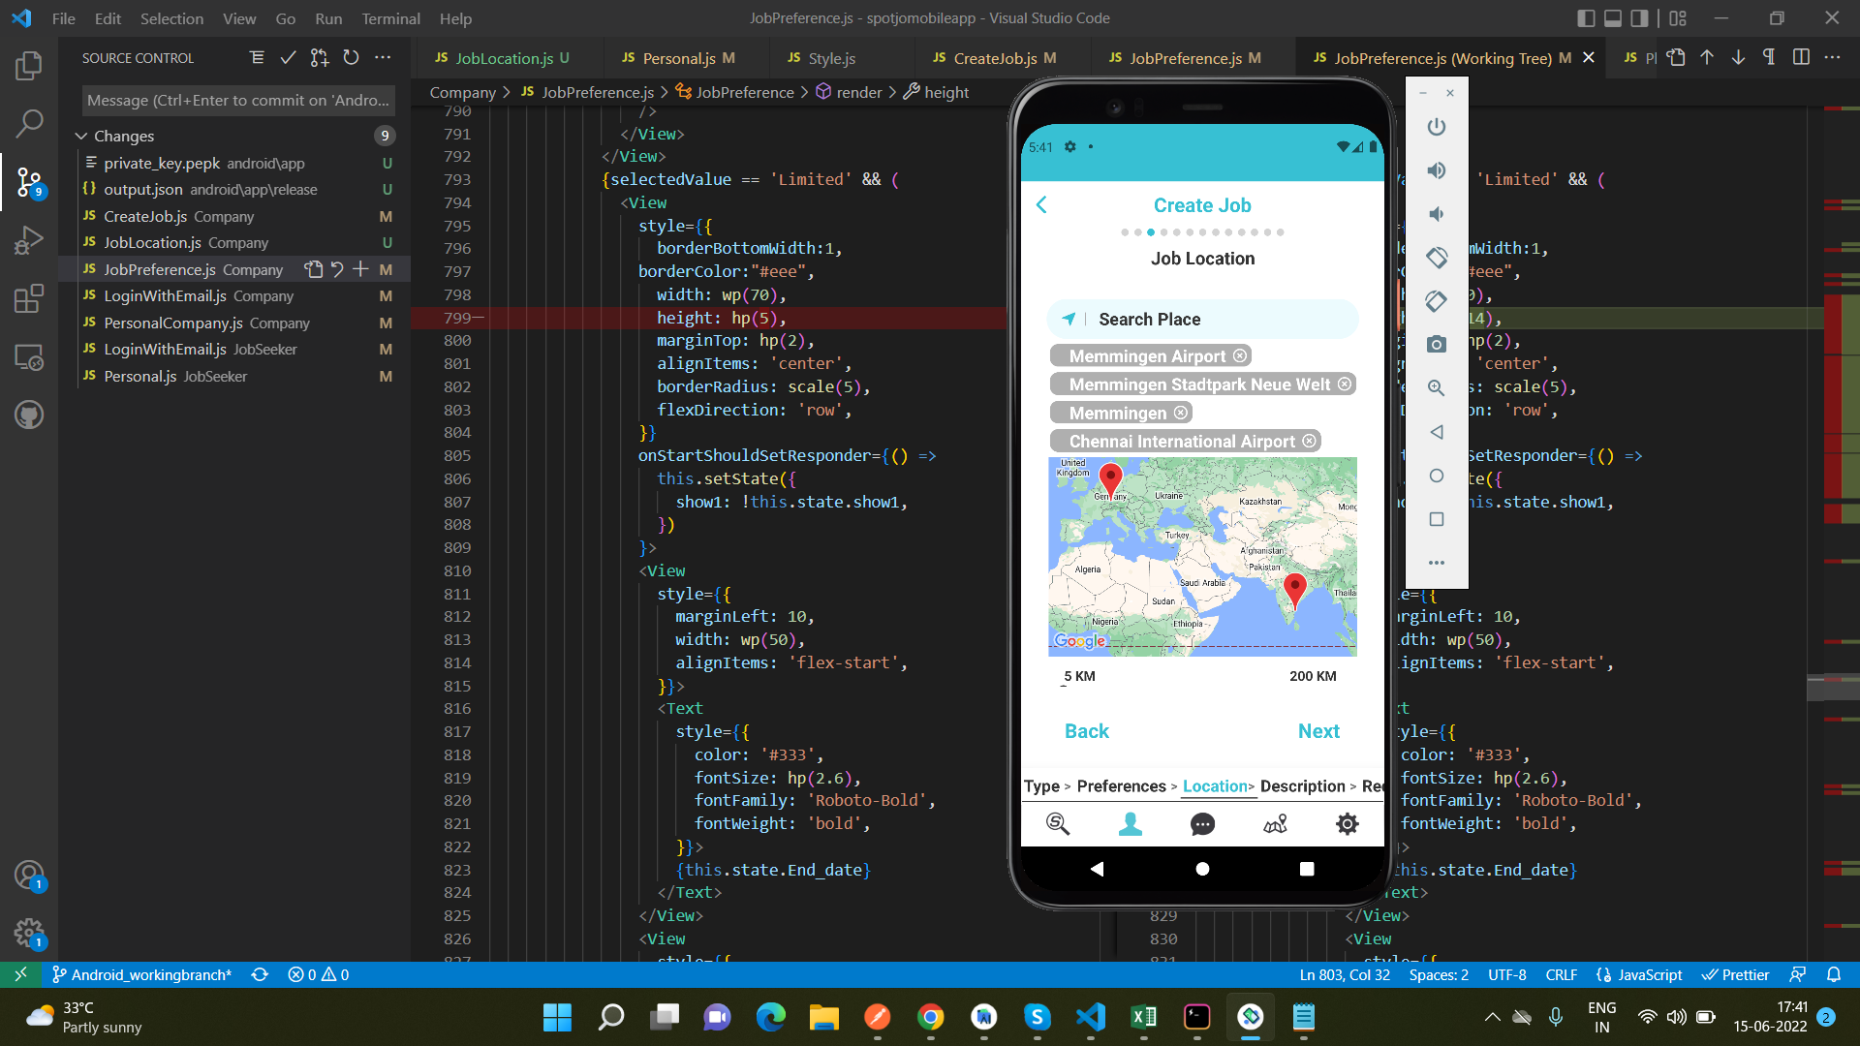

As can be seen in the screen shot, the spacing between the input field and the map is more than enough to fit 4 large named places.

## Job Preferences alignment

**DEFECT DESCRIPTION:**

In the Job Preference page, we used to have a field on the bottom of the screen, which we used to enter the location of the job posting. Now that we have moved the Job Location field to another new page, we have to adjust the alignments of the Job Preference page.

**SOURCE CODE FIX DONE:**

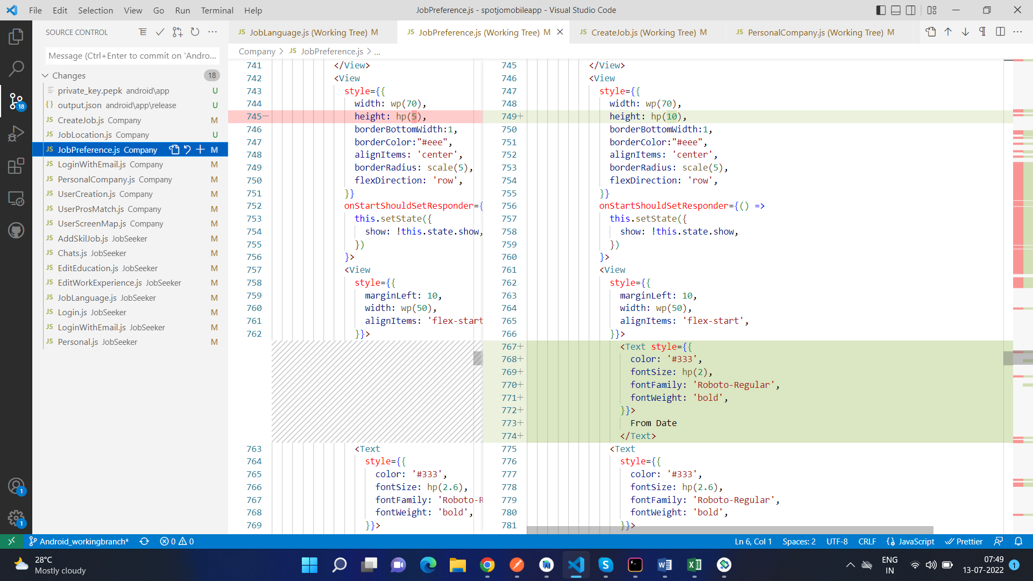

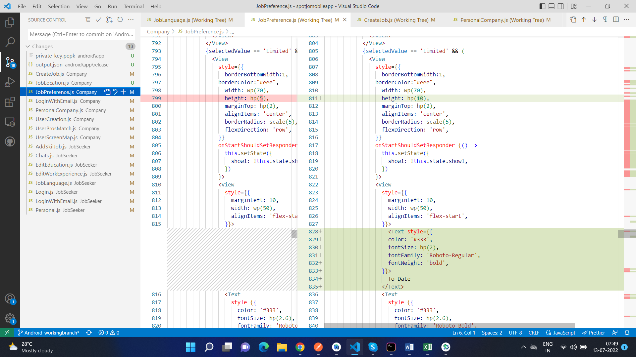

Here is how the page looks like after the code change:

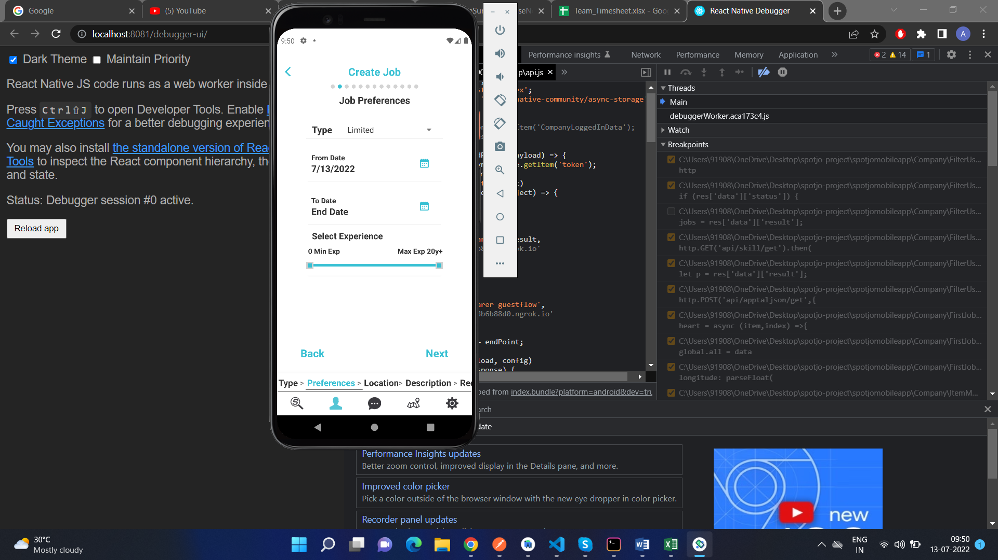

## Setting the default Starting Date of a Job to be of the current date:

**DEFECT DESCRIPTION:**

When we are creating a new job, and we are selecting the starting and ending dates for that job, we are unable to choose the current date (ie. today) as the starting date. So to fix that, we will have to set the current date as the default Starting date of the job.

**SOURCE CODE FIX DONE:**

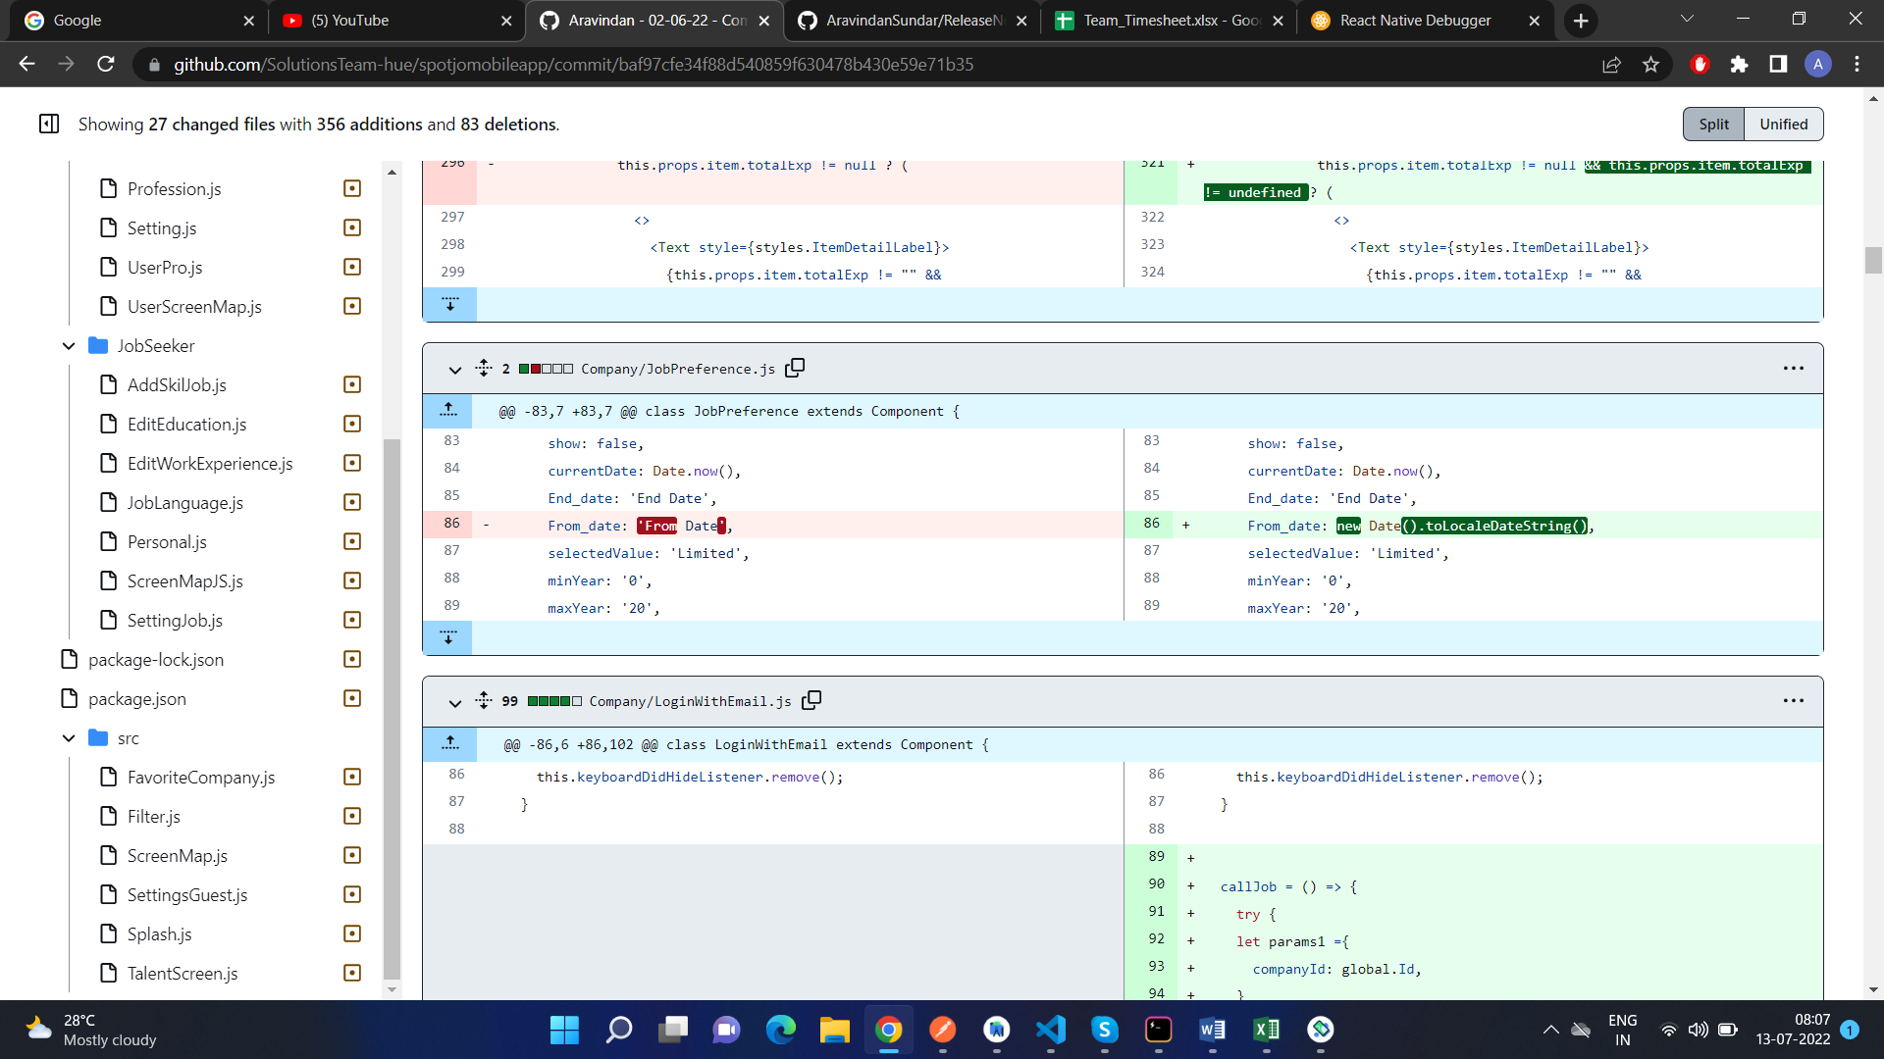

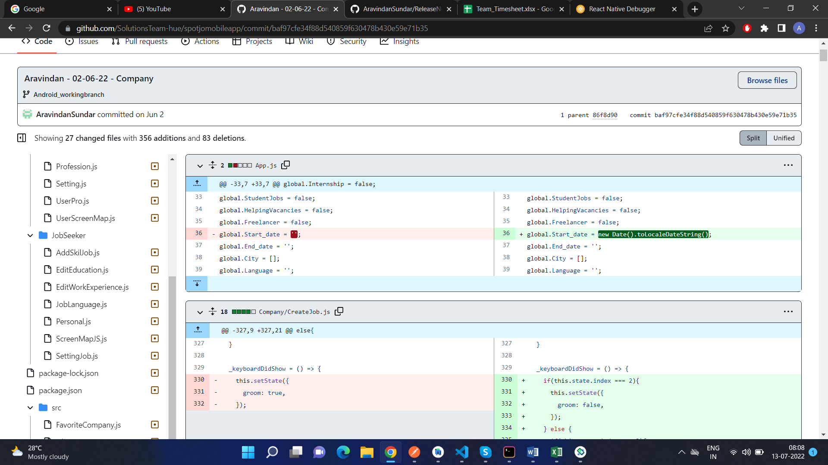

Here is how the page looks like after the code change:

